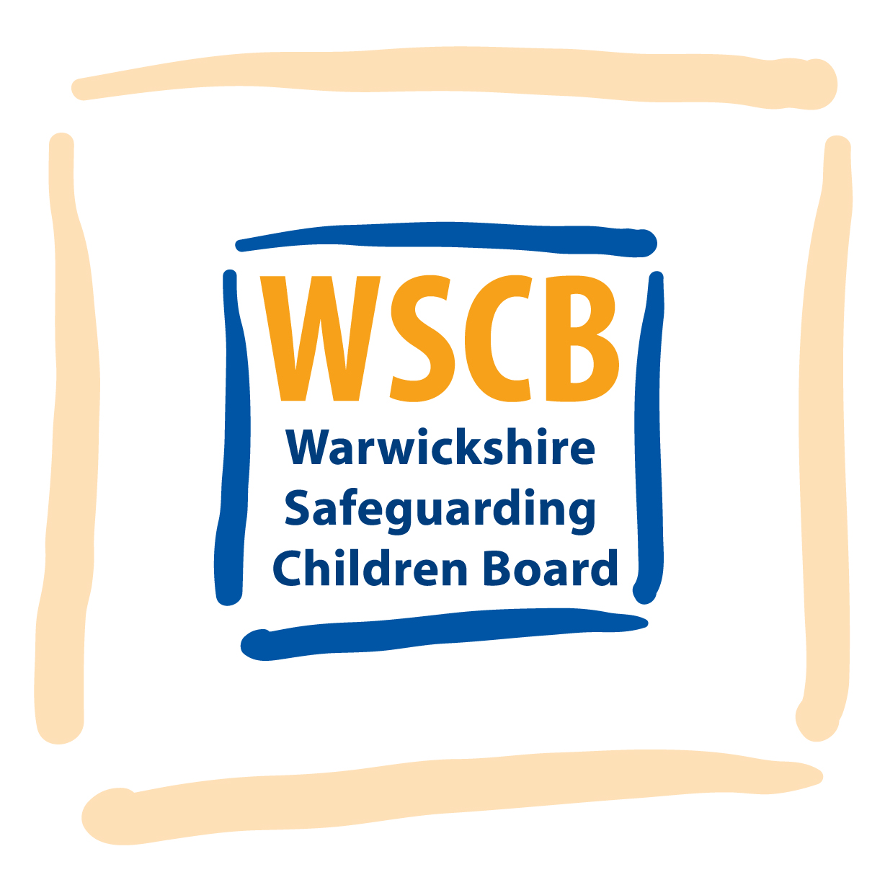

ANNUAL REPORT

2013

“Keeping Children Safe and Healthy”

**Contents**

|  |  |  |
| --- | --- | --- |
|  |  | **Page** |
| **1.** | **Forward by Chris Hallett – Independent Chair** | **2** |
| **2.** | **Local Background and Context** | **3** |
| **3.** | **Statutory and Legislative context for the Safeguarding Children Board** | **5** |
| **4.** | **Governance of WSCB** | **6** |
| **5.** | **Progress against Strategic Objectives**  5.1 Create and Maintain a learning System  5.2 Strengthen Accountabilities  5.3 Promote Effective Practice  5.4 Promotion of Early Help for Children, Young People and Families | **13**  **18**  **25**  **27** |
| **6.** | **Effectiveness of Safeguarding Children arrangements in Warwickshire** | **29** |
| **7.** | **Business Plan for 2013-2014** | **47** |

1. **Forward by Chris Hallett - Independent Chair.**

In previous annual reports I have commented how the important business of safeguarding children is taking place in a very difficult economic and organisational climate. This has continued to be the case this year. The Board has received regular reports from agencies at each of its meetings describing how they are managing these challenges. In many ways this is being done effectively although there are now worrying signals in respect of early help reductions for families which in the longer term could well lead to more children being placed in vulnerable situations. The Board intends to monitor the impact of changes in early help settings over the next year.

This year has also seen significant changes to key personnel within agencies with experienced professionals leaving Warwickshire. It is well known that staffing changes or gaps can be crucial to maintaining effective services so whilst we welcome new members to the Board we hope they can now settle into their roles and contribute to the continuing challenge of keeping children safe in Warwickshire.

Dealing with change whilst maintaining effective services remains a crucial aspect of 2013-2014. New national guidance on Working Together 2013 is being embedded in our practice. The challenge of dealing effectively with child sexual exploitation has led the Board to instigate new strategies and procedures as well as a tool kit for practitioners. National media has exposed several high level incidents of children being exposed to sexual exploitation and Warwickshire needs to continue to be vigilant and well prepared to tackle this area of abuse.

No one should be in any doubt as we contemplate the year ahead of the ongoing task of keeping children safe in Warwickshire. Board members, Associate members and members of the various subcommittees and working groups have worked hard and without their dedication and diligence the progress made as highlighted in this Annual Report would not have been achieved. I thank them all for their continued contributions.

Chris Hallett

Independent Chair WSCB

**2. Local background and Context.**

Warwickshire is a two tier County Council in the West Midlands composed of five district/borough Councils. The demography of the county varies markedly from district to district, with the south of the county in general being more affluent than the north, which features significant deprivation in parts.

Deprivation covers a broad range of issues and refers to unmet need caused by a lack of resources of all kinds, not just financial. The English Indices of Deprivation use various indicators across seven distinct domains of deprivation, which can be combined to calculate an overall relative measure of deprivation – The Index of Multiple Deprivation 2010 (IMD 2010). Although it should be noted that much of the data used to construct the indices relate to the year 2008. The Indices of Deprivation 2010 show that Nuneaton & Bedworth Borough has the highest levels of deprivation in Warwickshire with a ranking of 108 out of 326 Local Authority Districts in England, according to the rank of average score measure of deprivation (where a rank of 1 indicates the most deprived authority). This means Nuneaton & Bedworth are within the top third most deprived Local Authority Districts in England. There are nine Lower Super Output Areas (LSOAs) in Warwickshire ranked within the top 10% most deprived SOAs nationally on the overall Index of Multiple Deprivation 2010. These are all located within Nuneaton & Bedworth Borough. Stratford on Avon District is the least deprived District in the County, ranked 278th out of 326 Local Authority Districts. In between, North Warwickshire is ranked 182nd, Rugby 219th and Warwick District 257th.

The table (see next page) contains additional socio economic contextual indicators highlighting the disparity between the North and the South of the County in terms of unemployment, worklessness and economic hardship, impacting on family cohesion, educational outcomes, health and general wellbeing. Like any District level measure, local variations and concentrations of deprivation will be masked across all five Districts and Boroughs. For example, two areas in Nuneaton and Bedworth recorded over 50% of children living in “poverty” according to the HMRC measure, and further areas in Warwick, Rugby and North Warwickshire with over a third of children.

It is also worth noting that as part of Troubled Families programme which aims to tackle the root cause of problems that cause truancy, youth crime, anti-social behaviour and worklessness, almost 800 families have been identified that meet three of the identified criteria (national and local criteria) within Warwickshire. Almost half of these families reside in Nuneaton and Bedworth Borough (47%). Child protection was one of the areas used to identify these families.

**Socio-Economic Indicators**

|  |  |  |  |  |
| --- | --- | --- | --- | --- |
| District | Jobseekers Allowance (June 13) % working age population | All DWP working age benefit claimants (Nov 12) % working age population | % of Children in “Poverty”* (August 2010) | Free School Meal Eligibility (Jan13) % pupils attending maintained school in Warwickshire eligible for FSM |
| North Warks | 2.1% | 11.2% | 14.2% | 11.3% |
| Nun. & Bed. | 3.5% | 14.9% | 19.6% | 15.1% |
| Rugby | 2.3% | 9.6% | 13.7% | 10.1% |
| Stratford on Avon | 1.0% | 7.8% | 10.0% | 7.1% |
| Warwick | 1.6% | 8.3% | 11.6% | 9.2% |
| **Warwickshire** | **2.1%** | **10.3%** | **13.9%** | **10.6%** |
| England | 4.1% | 13.8% | 20.6% | 18.3% |

*Source: NOMIS, School Census, HMRC *Number of children living in families in receipt of CTC whose reported income is less than 60 per cent of the median income or in receipt of IS or (Income-Based) JSA, divided by the total number of children in the area (determined by Child Benefit data)*

Warwickshire continues to have Children’s Trust arrangements and these too operate at two tiers. The Countywide Children and Young People’s Plan has three priority outcomes, Achievement, Health and Safeguarding these are supported by four areas of priority work: the positive contribution of young people, early intervention through integrated working, effective commissioning, and resources and infrastructure. These priorities fit well alongside those of the Safeguarding Children Board, and particularly welcome is the emphasis on early intervention and integrated working.

**3. Statutory and Legislative context for LSCBs.**

Local Safeguarding Children Boards (LSCBs) were established by the Children Act 2004 which places the responsibility on Local Authorities to co-ordinate an LSCB in their area.

The role of the Board is to co-ordinate local multi-agency safeguarding arrangements and evaluate the effectiveness of these arrangements. To do this the Board has several functions it must perform, including producing local inter-agency safeguarding procedures, reviewing the deaths of all children in its area to identify learning which may prevent future child deaths, conducting Serious Case Reviews into the deaths of any children where child abuse or neglect are known or suspected, or cases where children are seriously harmed by abuse or neglect and poor multi-agency working may have been a factor, and publishing an annual report on the effectiveness of child safeguarding arrangements in the area.

Safeguarding Boards must include senior members of staff from Local Authority children’s and adult’s services, District/Borough Councils, Police, Health Service, Education, Youth Justice, Probation and the Careers Service, and they should be chaired by someone suitably experienced in safeguarding children who is independent of the partner agencies.

**4. Governance and Accountability arrangements.**

Warwickshire Safeguarding Children’s Board has an independent chair, Chris Hallett. In addition to the Chair, the Board directly employs three members of staff, the Development Manager, Inter-agency Training officer, and an Administrator, these posts are hosted by the County Council and funded by the contributions made by member organisations as set out below.

The Child Death Overview functions are managed and supported by a team of two staff, the CDOP Manager and an assistant. This arrangement is made in co-operation with Solihull and Coventry, with the CDOP team working on behalf of all three CDOP panels. The posts are funded jointly by Warwickshire County Council, Coventry City Council and Solihull MBC, in addition to the funding provided by the local authorities directly to the respective Safeguarding Children Boards.

**Board Meetings.**

In 2013-2013 WSCB met quarterly on 23rd May 2012, 26th September 2012, 5th December 2012 and 6th February 2013.

**Structure of Warwickshire Safeguarding Children’s Board.**

# Warwickshire Safeguarding Children Board

(WSCB)

Senior Management Representatives

#### from Agencies, Designated Leads and Lay Members

# CSW Partnership Connexions

# Warwickshire Children & Family Court Advisory and Support Service

District/Borough Councils in Warwickshire

Warwickshire County Council People Group

Warwickshire Domestic Abuse Services

Warwickshire Health Trusts

Warwickshire Police Service

Warwickshire Probation Trust

Voluntary and Community Sector

Warwickshire Youth Justice Service

Legal Advisor

Associate Members

Chairs Group

Subcommittees

# Child Death review

# Panel

Schools, Learning and Education

# Health

# Systems, Procedures

& Guidelines

Performance, Evaluation and

&

Monitoring

District Councils

Training

# Special Cases

Strategy

Communication,

and Information

**Board members as of 31/3/2013:**

**Chris Hallett (WSCB Independent Chair)**

**Jacqueline Barnes**

Associate Director of Nursing NHS Warwick and NHS Coventry

**Maria Barnes**

Service Manager North Safeguarding – People Group, Warwickshire County Council

**Detective Superintendent Amanda Blakeman**

Warwickshire Police

**Jenny Butlin-Moran**

Service Manager Child Protection - People Group, Warwickshire County Council

**Jackie Channell**

Designated Nurse Child Protection – NHS Coventry and NHS Warwickshire

**Mel Coombes**

Associate Director of Nursing–Coventry and Warwickshire NHS Partnership Trust

**Martin Cowan**

Housing Advice Manager, Stratford District Council

**Craig Dicken**

Communities Officer (Equalities and Cohesion) - Nuneaton and Bedworth Borough Council

**Hugh Disley**

Head of Service Early Intervention – People Group, Warwickshire C.C.

**Keith Drinkwater**

Lay Member and Vice Chair

**Liz Elgar**

Service Manager - Coventry and Warwickshire CAFCASS

**Wendy Fabbro**

Strategic Director – People Group, Warwickshire County Council

**Victoria Gould**

Young People’s Legal Services Manager, Warwickshire County Council

**Jodie Green**

Youth Work Officer, NFYF Clubs - Representative of the Warwickshire Voluntary and Community Sector

**Cornelia Heaney**

Development Manager - Warwickshire Safeguarding Children Board

**Helen Hipkiss**

Assistant Director Patient Experience, NHS West Midlands

**Sue Ingram**

Domestic Abuse Manager – Community Safety, Drugs and Alcohol Action Team, Warwickshire County Council

**Detective Inspector Nigel Jones**

Warwickshire Police

**Detective Chief Inspector Richard Long**

Warwickshire Police

**Jameel Malik**

Head of Housing/Property Warwick District Council

**Angela O’Boyle**

Lay Member

**Adrian Over**

Education Safeguarding Manager –People Group, Warwickshire C.C.

**Simon Powell**

Assistant Director (Community Development) - North Warwickshire Borough Council

**Phil Sawbridge**

Head of Service Safeguarding - People Group, Warwickshire County Council

**Steven Shanahan**

Head of Housing Services - Rugby Borough Council

**Dr Peter Sidebotham**

Designated Doctor Child Protection – NHS Warwickshire

**Mark Simmonds**

Inter-agency Training Officer - Warwickshire Safeguarding Children Board

**Calvin Smith**

Service Manager Safeguarding, People Group, Warwickshire County Council

**Steve Stewart**

Executive Director - Coventry and Warwickshire Partnership: Connexions

**Cllr Mrs Heather Timms**

Warwickshire County Council Lead Portfolio Holder for Children - People Group, Warwickshire County Council

**Lesley Tregear**

Service Manager - Warwickshire Youth Justice Service

**Andy Wade**

Assistant Chief Probation Officer – Warwickshire Probation Trust

**Alison Walshe**

Director of Commissioning Development, Arden Cluster NHS Coventry and NHS Warwickshire

**Jenny Wood**

Head of Social Care and Support – People Group, Warwickshire County Council

**WSCB Budget 2012 -2013**

|  |  |  |  |  |
| --- | --- | --- | --- | --- |
|  | | | | |
| Income | Children’s Services | 51,497 |  |  |
|  | Health | 32,952 |  |  |
|  | Police | 17,508 |  |  |
|  | Probation | 8,295 |  |  |
|  | CAFCASS | 550 |  |  |
|  | District Councils | 10,260 |  |  |
|  | CSWP | 1,025 |  |  |
|  | WCC Learning and Development | 41,050 |  |  |
|  | Sales | 320 |  |  |
|  | Fees | 950 |  |  |
|  |  | 183,500 |  |  |
|  |  |  |  |  |
| Expenditure  Staffing including travel,  Services and supplies (desks, PC, phone, stationery, photocopying, subscriptions, postage)  Training:  Room Hire  Catering  Monies not spent on SCR and re-print of ‘Blue Book’ which will be spent on Learning and Improvement Activities in 2013-2014 |  |  | 127,819  6,585    2,864  1,173  45,059 |  |
|  |  |  | 183,500 |  |
|  |  |  |  |  |

WSCB did not commission any Serious Case Reviews in 2012-13, nor was the anticipated re-print made of the inter-agency procedures, consequently an additional sum of £45 059 is carried forward into the budget for 2013-2014. The revised statutory guidance, ‘Working Together’, and the proposed framework for Ofsted inspections of LSCBs set out an expectation that the range and depth of quality assurance activities carried out by LSCBs will need to be more extensive than has been the case to date. It is therefore planned to use the money carried forward from previous years to commission external reviews in support of the new Learning and Improvement programme WSCB is developing. This will delay the need to look to partners for increased financial support to the Board for a period of time, and allow WSCB some time to formulate a view about a long term approach to undertaking this kind of activity.

**5. Progress against Strategic Objectives.**

The annual report for WSCB published last year set out the strategic plan for 2012-2015 under four strategic objectives derived from the Munro Review of Child Protection in England:

Create and Maintain a Learning System

Strengthen Accountabilities

Promote Effective Practice

Promotion of Early Help for Children, Young People and Families.

The work undertaken by WSCB and its sub-committees is clustered under these overarching objectives, and progress against them is set out below.

**5.1 Create and Maintain a Learning System.**

The approach to ‘Learning’ taken by WSCB is a holistic one combining the delivery of training and conferences with reflective learning derived from reviews and inspections of work done by partner agencies in Warwickshire and other LSCBs.

**Provision of Safeguarding Training.**

The Board has continued to run its own inter-agency training programme. This combines core training for a wide range of professionals whose work may bring them into contact with children, and also more specialist training for those who are directly involved in the delivery of early help and child protection plans. The programme is devised, co-ordinated and evaluated by the Inter-agency Training Officer, Mark Simmonds who also delivers much of it. Mark undertook a consultation exercise with some young people who have experienced the child protection ‘system’ in Warwickshire to ensure that their perspectives were reflected in the training materials. This year, the inter-agency training officer has also been providing child protection training to staff working in Adult social care teams, in keeping with the WSCB ‘Think Family’ strategy.

From September 2012 to July 2013 there have been 853 attendees at WSCB training. Attendance from within the different professional groups has been quite varied with most coming from social services, but others such as the Police sending 24 people, the voluntary sector 58 and health with 134. There were a total of 434 people attending the raising awareness safeguarding training, 120 of this figure were people who work in the adult sector which was offered to them over eight sessions specific to this group of professionals.

It was noticed that from September through to December 2012 the number of applications for training being offered had reduced to the point where six planned training sessions had to be cancelled. There are a number of possibilities why this may be so, and Mark has been undertaking some enquiry to better understand these. It is evident from feedback that for at least some agencies this includes the risk of hard pressed services facing cancellation charges if at the last minute staff cannot be released from service delivery.

We are not proposing that this changes WSCB’s stance with regards charges, however, it is felt to be helpful if we add in the Training Directory that it is appreciated that there can be unavoidable circumstances where cancellations have to be made and in those cases either the candidate or their manger contacts the training officer to discuss this. In effect this already occurs when managers contact the training officer to discuss the reason why a staff member had not been able to attend. The effectiveness of the charging policy is shown with the number of non-attendances over the past twelve months being just 5.

At the conclusion of the consultation /enquiry into falling numbers at training, the training offer will be revised to ensure it is meeting the learning needs identified, and other practical changes that may help will be considered.

**Training evaluation**

Training is always very well evaluated, to ensure this remains so two extra questions have recently been incorporated into the feedback questionnaire which ask delegates to feedback on the quality of the training, specifically “clarity of communication” and “method of delivery”. It was felt that these would help us to capture feedback on the trainer/s and so enable feedback to them and pick-up on any issues should they arise.

The WSCB Training Pool has continued to be a valued and very effective way of delivering WSCB’s awareness raising training needs around safeguarding. It will continue to be monitored to ensure it is able to operate effectively and to ensure its delivery of training is sustained. Recruitment to the pool will be kept under review and appropriate steps taken should the need arise.

A noteworthy achievement this year has been the rolling out of Child Protection training to GPs throughout Warwickshire, which was delivered by the Designated Nurse for Child Protection. Discussions are continuing between the Coventry and Rugby Clinical Commissioning Group and the Local Area Team about the practicalities of providing safeguarding training for other independent health professionals carrying out NHS work, such as dentists.

The Inter-agency Training Officer produces a report of training activity in the year which is available on the WSCB website.

**9th WSCB Annual Conference**

In October 2013 the 9th Annual Conference was held, which was entitled ’Evidence-Based Programmes in Safeguarding Children – Implementing in Warwickshire what works.’ This was an opportunity to learn about the work Warwickshire County Council have been doing with the Dartington Social Research Unit to better understand the pathways followed by children and young people who come into Local Authority care and how the looked after “system” and other interventions can be best utilised to meet their needs. By identifying groups with similar characteristics, appropriate evidence based interventions can be provided with the aim of diverting some of the children from care altogether, or returning others home more quickly and with an increased likelihood of return being successful. The conference also heard speakers from Dartington explain what is meant by ‘evidence based’, and considerations for evaluating the merits of various interventions that could be offered in a particular situation.

It would be expected that the extent of the effectiveness of the programme could take some time to be evident, but the early signs are encouraging. WSCB is now involved in a second phase of the project to look at evidence based approaches which could reduce the number of children needing a child protection plan and support more effective use of the child protection system. Work on this aspect began in April 2013.

**Munro Development Demonstrator Activities.**

Warwickshire County Council was successful in applying to be a ‘Munro Development Demonstrator Site’ and WSCB participated in several relevant Learning Events:

* **Learning about work to prevent Child Sexual Exploitation.**

Several members of the Board and partner agencies made a visit to the Blackpool ‘Awaken’ team which is a multi-agency co-located child sexual exploitation (CSE) team. Learning from this included the value of being able to offer consistent workers to young people over long periods of time to enable them to build up trust and feel supported, the need to provide good support to the staff doing this work as it can be emotionally draining, the value of co-location to enable the sharing of ‘soft’ intelligence, and build up a local picture of CSE activity, and some approaches to supporting young people to be good witnesses in criminal proceedings. This information is being considered by partners in the consideration of how to shape Warwickshire’s response to CSE.

Further to this visit, WSCB signed up to the National Working Group for CSE, in order to be able to continue learning from the experiences of other areas, and relevant staff are attending the Forums.

* **Stoke on Trent and Staffordshire MASH.**

WSCB partner agency staff attended a conference sharing learning from the first year in operation of the Staffordshire and Stoke on Trent Multi agency Safeguarding Hub (MASH). Learning from this will be shared at a workshop for WSCB and WSAB members in the autumn of 2013 as partner agencies in Warwickshire consider whether this is an approach to multi-agency working that would add value in Warwickshire.

* **Evaluating Systems Review methodologies.**

Two case reviews using aspects of systems review methodologies were undertaken and evaluated in preparation for the anticipated changes to statutory guidance on the conduct of Serious Case Reviews. (SCRs) The first was a case review commissioned by the Special Cases sub-committee for a case which did not meet the mandatory SCR threshold. This review was undertaken by the Development Manager (Vic Tuck) and included the use of the ‘conversations’ with front line staff that are key to the SCIE ‘Learning Together’ review methodology. The second was a single agency review commissioned by Children’s Social Care using ‘SILP’ (Significant Incident learning Process), another systems review approach, developed by Paul Tudor. The SILP methodology was evaluated as a Munro Development Demonstrator Site activity by the Development Manager (Cornelia Heaney) with a view to considering the value of its possible application for local case reviews and SCRs commissioned by WSCB.

Both these reviews illustrated the value of hearing from staff directly involved to understand the ‘local rationality’, i.e. why the actions that were taken seemed sensible or even obvious at the time, and that this can provide a way of getting beyond adjusting parts of the process, and increase the ability to examine the functioning of interacting parts of the system. The learning will be put into practice in reviews being conducted in the current year.

**Child Death Overview Panel. (CDOP)**

WSCB CDOP has continued to meet throughout the year to review the deaths of children in Warwickshire. This statutory duty is intended to ensure that factors contributing to the death which may have been modifiable are identified and fed back to the relevant agencies to try and reduce such factors being a feature of child deaths in the future. Warwickshire works in partnership with Solihull and Coventry to share a CDOP team, composed of the CDOP Manager and an assistant. As well as being a practical and cost effective solution, this enables learning in the sub-region to be shared. Anonimised data is reported by all areas to the Department of Education, but the reviews held by our colleagues in the sub-region are particularly relevant to learn from because of the overlap in health and third sector resources, and the mobility of families across county borders which means that identified modifiable factors have more shared applicability.

As a result of learning from reviews in recent years, a ‘Safe Sleeping’ Campaign was held to promote information to parents and carers that is known to be relevant to preventing Sudden Infant Death.(SIDS). In the following year, the number of SIDS deaths reduced, but those that were reviewed still featured some modifiable factors, and worryingly, in the cases where parents were asked, they had heard the safe sleeping information but had chosen to apply it selectively. This year, The CDOP Manager held a conference to share information with partners in the sub-region about the Derby ‘safe sleeping’ assessment, which is a tool used by midwifes and health visitors in Derby to work pro-actively with parents to maximise the safety of infant sleeping arrangements. Midwifery leads in Warwickshire and another authority in the sub-region are developing local use of the tool to try and further reduce infant deaths with modifiable factors.

Other changes in Warwickshire brought about as a result of learning from CDOP reviews included the provision of new equipment, and training in its use, in Delivery suites, clarified practice guidance given to staff in a range of health settings, and improving signage on challenging stretches of road. In 2013-14 The CDOP Manager is seeking to work with the County Council Business Intelligence team to undertake and analysis of the data collected in the sub-region over the 5 years the panels have been in operation to see what be learned by looking at the data in the round.

The CDOP Manager produces a full report of CDOP activity in the sub-region, and this is available from the WSCB website*.*

**Serious Case Review.**

No serious case reviews were initiated during the year.

**Local Case Reviews.**

Two case reviews were commissioned by WSCB to learn from cases which did not meet the mandatory SCR threshold. The learning from these cases resulted in work including:

* Ensuring that only qualified social workers undertake statutory assessments of children in need.
* Social Care and Housing are working together to ensure that the commissioning arrangements address the housing needs of vulnerable young people.
* A review of the joint protocol for homeless 16 and 17 year olds between housing and social care is being undertaken.
* Introduction of "Edge of Care” meetings for this group of young people.
* Further Work to explore the interface between CAF and Social care which has informed the revision of the protocol, and
* Introduction of the practice of undertaking a core assessment when a number of initial assessments have previously been undertaken.

**5.2 Strengthen Accountabilities.**

**Quality and Effectiveness of Practice.**

In May 2012 WSCB agreed an update to the Performance Management Framework**,** which draws together the various review and audit activities of the Board into one framework. This includes the implementation of the Board’s strategic objectives, monitoring of actions plans drawn up in response to inspections, monitoring of agency audits of the effectiveness of their safeguarding activity, and monitoring actions agreed in response to case reviews together with the use of the Case Escalation Process.

**External Inspection**.

There has been a substantial amount of activity during the year responding to the findings of external inspection, this is summarised below.

* **Ofsted and CQC joint inspection of Safeguarding and Looked After Children.**

It was reported last year that this inspection conducted in October and November 2011 found the overall effectiveness of safeguarding in Warwickshire to be ‘good’. However there were recommendations for improvement, and action in response to these continued into this year, with progress of this monitored by WCSB. This has included:

Revising the written statement of Thresholds for Intervention and promoting this eg by including it in inter-agency training, publishing on the WSCB website, and circulating to partners through an email circulation list.

Children’s Social Care Operations Managers took part in an exercise to review how thresholds were interpreted locally throughout the County. Work to improve the consistency of threshold application is continuing, and is a theme of the new phase of the Dartington Social Research Unit work referred to in 5.1 above.

Training has been provided to all the GP practices in Warwickshire. Responsibility for oversight of training sufficiency and quality in NHS provider organisations sits with the Coventry and Rugby Clinical Commissioning group from April 2013, and they have created the post of a Training Lead to assist with this.

Work has begun, and is continuing, to ensure child protection plans are ‘SMART’ and have well defined intended outcomes.

* **Ofsted Thematic Inspection: Parents with Mental Health and Substance mis-use Problems, ‘What about the Children?’**

This inspection was carried out in several areas across England, including Warwickshire. Local learning from this inspection resulted in a number of actions being taken in Warwickshire:

The development of a ‘Think Family’ protocol which has been adopted by both the Children’s and Adult’s Safeguarding Boards,

The development of a Think Family Board which will act as a vehicle for taking forward a number of the issues identified by the thematic inspection and resultant report.

* **Joint inspection by HMIC et al looking at Appropriate Adult arrangements and detention after charge, ‘Who’s Looking out for the children?’**

This report was published in November 2011, and in response Warwickshire Youth Justice Service drew up an action plan which aims to:

* Agree a new protocol with Police to set timescales and standards for managing young people detained in police cells,
* Improve timeliness and quality of appropriate adult service to young people,
* Implement a range of measure to address the vulnerability of young detainees, such as provision of health assessment and privacy when booking in,
* Increase the number of transfers to Local Authority accommodation. (‘PACE beds’).
* Develop arrangements for getting relevant service user views.

WSCB will seek information about the implementation of these arrangements in 2013-14.

* **HM Inspectorate of Probation led Joint Inspection of Offender Management in Warwickshire.**

This inspection was conducted in May 2012, and was positive overall with high scores (and ‘minimum’ improvement required) for many areas assessed. However some recommendations were made to improve safeguarding of children, namely improving the management oversight of cases where child protection risks were identified, and ensuring that objectives to deal with child protection issues are included in all sentence plans.

A report on progress to address these recommendations will be made to WSCB in 2013-14.

* **Ofsted Thematic Inspection: Protecting disabled children.**

This inspection report was published in August 2012, and Warwickshire Integrated Disability Service conducted a review of their children’s safeguarding practice in the light of its findings. The multi-agency team was found to offer many strengths, and the arrangements for co-working with child protection social work teams when required was considered to be sound. However it was also noted that the number of child protection plans in respect of children with profound disabilities was low (averaging 4 at any time), and although this could be explained by the amount of support available to the families of these children it is also possible the figure is explained by poor recognition of child protection needs among severely disabled children, and so it is proposed that this will be the subject of future audit activity.

WSCB also noted that the services to Deaf children were given as part of an all ages specialist service, and in 2013-14 intends to commission an audit of children’s safeguarding within this service to ensure the particular safeguarding needs of Deaf children are being met within it.

* **HMI Probation led Joint Inspection of Youth Offending Work in Warwickshire.**

Warwickshire Youth Justice Service was inspected in October 2012. The inspection found that youth offending work in Warwickshire was good, with staff committed to producing good outcomes and to safeguarding young people, and with good governance of the Youth Justice Service. However there were two findings which posed a challenge in relation to inter-agency safeguarding practice in Warwickshire. The inspectors found that the WSCB procedures relating to child sexual exploitation (CSE) were not sufficient to support good practice, and that there was ineffective escalation of safeguarding referrals to Children’s Social care resulting in an inadequate response to some identified cases of sexual exploitation.

WSCB has made the development of a CSE strategy and an inter-agency procedure reflecting current best practice a priority work area, and both of these were ready to be signed off at the WSCB meeting May 2013. The escalation process continues to be promoted at WSCB training events, and further work will be done in 2013-2014 to identify how to embed it fully in inter-agency safeguarding practice.

**Audit activity: Audit of compliance with statutory safeguarding requirements (‘s.11’)**

Preparation began for the completion of a new audit of the compliance of partner agencies with the statutory requirements on them to engage in safeguarding and promoting the well-being of children. The decision was made to undertake a full audit because there has been significant change in the makeup and status of organisations since the last similar audit was undertaken by WSCB in 2011, for example the winding up of PCTs and establishment of Clinical Commissioning Groups, schools obtaining Academy status and becoming independent of the Local Authority and the winding up ‘Connexions’ and establishment of CSWP. Following consultation with colleagues in the Health and Education sub-committees, a tool has been developed which is aligned with others used in the sub-region to streamline work for agencies operating in more than one LSCB area, and this will be sent out in the early autumn of 2013.

Changes to the previous S.11 audit include more enquiry about the sufficiency and reach of safeguarding training and the request for more illustrative evidence.

**Monitoring of actions from Serious Case Reviews.**

The Health, and Schools and Learning sub-committees of the Board continued to monitor the action plans drawn up following the SCR conducted in the previous year. Continued audit in the Arden cluster has demonstrated compliance with the requirement to record the names of children’s fathers, and to record the identity of adults accompanying children at a contact, and also shown satisfactory notification to health visitors and GP of children’s presentation at unscheduled care centres in the Arden Cluster.

The Education action plan was completed with the signing off and circulation of guidance to early years settings and schools on the recording of parents and others with parental responsibility in a child’s records.

**Warwickshire Safeguarding Children Board Escalation Processes**

Warwickshire Safeguarding Children Board (WSCB) recognises that in most circumstances, the application of the provisions of the Children Act 1989 and the four categories of harm to children set out in the *Warwickshire Safeguarding Children Board Interagency Child Protection Procedures,* make it possible for professionals to refer cases appropriately and for there to be agreement between the Children’s Team and the referrer on the status and disposal of the referral.

However, the Board also recognises that there are situations where disputes over thresholds for referral to social care, and initiation of child protection procedures may occur.

Similarly, the Board acknowledges that in most cases professional practice involving the safeguarding of children in Warwickshire is of a high standard. However, on occasions, concerns about professional practice may be raised.

Government reports and Serious Case Reviews conducted in Warwickshire show us that when children are subject to chronic child abuse and repeated or prolonged involvement in child protection processes, there is a danger of these complex cases “drifting”. In these cases, the risks to children may become particularly acute and there is an increased likelihood of a serious incident arising. The emotional and psychological damage to these children is also likely to accumulate if there is no demonstrable improvement in their care. The escalation process has been reviewed to include measures to address the possibility of ‘drift’ for such cases, and it is now a four part practice framework document which covers the following areas:

* Referrals where the threshold for intervention is contested.
* Situations where there are concerns about professional practice.
* Children subject of a child protection plan exceeding 15 months and 33 months
* Children subject to more than 1 child protection plan

Taken together the four parts are seen as forming an integrated approach to escalation processes in Warwickshire.

**Review of cases under the third and fourth criteria in 2012 -2013**

In respect to children subject to a child protection plan for longer than 15 months an enhanced risk analysis is completed at the review conference to ensure all agencies remained focused on the change required to ensure the child’s safety.

Where a child has been subject to a previous child protection plan focused attention is given to the request for a further conference. Discussions take place between the Independent Reviewing Service and Operational teams to ensure that any further plans are developed in full cognizance of the history on the case.

The case of any child subject to a third child protection plan will be the subject of scrutiny by the Performance Monitoring and Evaluation sub- committee of the board The task of the committee is for members to satisfy themselves that the child protection plan is progressing satisfactorily or to make a decision that a more Independent Review is required.

During the period 2012 -2013 12 families (23 Children) were subject to a third child protection plan in Warwickshire. In some cases only one of the children within a sibling group may have been subject to a third plan but all of the children are included in these figures.

After scrutiny 7 cases were considered to be progressing satisfactorily. In 5 of the cases a member of the committee conducted a more in depth review of the case and made recommendations where necessary to ensure the plan was not blocked in any way.

Legal oversight was maintained on all cases as an additional measure to ensure appropriate actions within planning.

In all cases the sub -committee was able to satisfy itself that plans were appropriately on track.

The figures for children subject to a second child protection plan in Warwickshire have improved over the last year.

|  |  |  |
| --- | --- | --- |
|  | 2012 | 2013 |
| % of children subject to a second or third child protection plan. | 16.5% | 13.3% |

The evidence would suggest that the use of escalation processes can contribute to more robust child protection planning and increased confidence in multi-agency decision making processes.

**Other Quality Assurance activity.**

* **DCS ‘Test of Assurance’.**

At the completion of the first year in operation of the County Council ‘People Group’, WSCB sought information from the Leader and the Chief Executive of the County Council that the Director of the People Group, which holds the combined statutory responsibilities of Director of Adult Services and Director of Children’s Services (DCS) was able to satisfactorily carry out the duties in respect of children.

The chair of WSCB had a meeting with the Leader of the Council and the Chief Executive to discuss the effectiveness of the DCS arrangements, and a formal report of this information was scheduled to be presented to the Board at the February 2013 meeting. Although the paper had to be put back until May, the information provided in this process set out the approach taken by the County Council to ensuring there is effective strategic leadership to children’s safeguarding, including the importance of the support provided to the DCS in this respect by the Safeguarding Head of Service.

* **Seeking information about the consideration given to safeguarding by the Health and Wellbeing Board.**

The WSCB Chair wrote to the chair of the Health and Wellbeing Board to seek reassurance about the priority being given to safeguarding in their work plans. A report was made to the Board in February which affirmed their intention that Safeguarding would be one of their priority areas. WSCB will seek further information about how this develops as the Health and Wellbeing Board establishes itself.

* **Safeguarding procedures and the safeguarding components of SLAs for the Clinical Commissioning Groups**

The Health sub-committee scrutinised the safeguarding elements of the arrangements being put in place by the establishing Clinical Commissioning Groups, including the contracts for designated nurse and doctor, Safeguarding procedures, and SLAs for service providers.

* **Ofsted ‘Good Practice by Local Safeguarding Boards’ Health check**

The Strategy and Communications sub-committee has initiated a self-assessment ‘health check’ of the functioning of the Board using questions suggested in the Ofsted ‘Good Practice; report. This will be completed during 2013-14, and will provide a basis for developing the approach that WSCB takes to increasing its own effectiveness.

**5.3 Promote Effective Practice.**

**Provision of Policies, Procedures and Guidance.**

Throughout the year a range of procedures and policies have been developed, and others reviewed. Significant among these is a major revision of the inter-agency child protection procedures, which has been the main work strand for the Systems and Procedures sub-committee. Unfortunately, the expected publication of ‘Working Together’, the statutory guidance for inter-agency safeguarding did not materialise in 2012, appearing finally towards the end of March 2013. The final review of the procedures therefore was held up for this, and the procedures were not published during the year as hoped. However, the decision was taken that this edition of the WSCB procedures will be published on-line only enabling continued revision of the procedures to take place more readily in the future as it will be much easier to review the document one section at a time.

**Child Sexual Exploitation Procedures**

New Child Sexual Exploitation Procedures were however completed, as a stand-alone document. This procedure sets out responses to CSE at all stages of the safeguarding continuum, from prevention to immediate safeguarding in high risk situations, and is accompanied by a set of tools to support practitioners in recognising signs of CSE, judging the level of risk and developing a plan to respond. A training strategy to support the new procedure is being developed by the Training sub-committee. The material is informed by research done by the University of Bedfordshire and Barnados, and by the experience of colleagues in other LSCBs.

This is a new approach in Warwickshire, and will be reviewed after the procedure has been in operation for a year.

**Child Sexual Exploitation Strategy and Improvement Plan.**

WSCB has drawn up a CSE strategy and associated improvement plan which addresses the four themes of raising awareness of CSE, improving the statutory response and service provision, improving the evidence base, and increasing prosecution and disruption of offenders. A new sub-committee of the Board is being established to drive this work.

**CDOP Protocol for the Involvement of Parents, Families and Carers.**

A Protocol has been agreed for the involvement of significant people in the life of the child whose death is being reviewed. Further work has been done, led by the CDOP Manager, to implement this in the sub-region. This has included developing a leaflet for parents and carers and agreeing the processes for who will give this to them, and how they will be supported. The protocol will be implemented during 2013-2014

**Private Fostering.**

The County Council recruited a Practice Leader for Private Fostering, Jenny Packeer, in December 2012, and this appointment has enabled work to be done updating Private Fostering paperwork and procedures and awareness raising activities amongst both the public and professionals about what Private Fostering is and the duties parents and private foster carers have to report this to the Local Authority for assessment.

The numbers of assessed Private Foster care arrangements in Warwickshire remain low (4 on the 31/3/2013), but the Practice Leader for Private Fostering is receiving a growing number of enquiries from people asking if situations need to be assessed, including from the Family Group Conference service of the County Council, school teachers, CAF officers and Independent Reviewing Officers as well as children’s social workers. Not all are Private Fostering arrangements at the time of enquiry, but the enquiries indicate a growing awareness of this issue. Many have followed on from training/ briefing events, which would appear to suggest this is an effective way or increasing awareness amongst professionals. A full report of Private Fostering Activity in 2012-2013 will be compiled separately for consideration by WSCB.

**WSCB - MAPPA Joint protocol**.

A WSCB- MAPPA (Multi-agency public protection arrangements) protocol was agreed, and signed by the chair of each body in December 2012, in order to formalise the co-operation between the two bodies. MAPPA co-ordinates the management in the community of offenders posing a risk of harm, including those who pose a risk of harm to children and registered sex offenders.

In the main, prior to the establishment of the Protocol, the co-operation between agencies in Warwickshire had been good. However since formalising the links between the two bodies, attendance by a WSCB representative at all MAPPA meetings has been consistent, which has helped to put in place better risk management plans to manage the risk sex and dangerous offenders pose to the public of Warwickshire, in particular, children. MAPPA also now makes a formal contribution to the work of WSCB through the participation of the MAPPA chair in the Strategy and Communication sub-committee.

**5.4 Promotion of Early Help.**

The inclusion of ‘Early Help’ in the agenda of Safeguarding Children’ Boards is a new development, and much of the work in Warwickshire this year has been in relation to better understanding the range and scope of the Early Help provision in the County. The Strategy and Communications sub-committee is tasked with establishing the processes by which the effectiveness of Early Help plans will be evaluated, which requires knowing not just how well each project is functioning, but also understanding whether, taken together, Early Help services reach all reasonable need. The Early Intervention Business Unit of the County Council People Group is drawing up an Early Help and Support Policy, which will provide the basis of this process.

Information reports were requested and considered from early intervention services, including an overview report from Hugh Disley, Head of Service, Early Intervention Business Unit who reported the following services currently being provided in Warwickshire:

* Family and Parent work including Family Group Conferences, Triple P training, etc.
* The Common Assessment Framework (CAF) which engages and works with families who have identified issues, supported by a team of CAF officers employed by the County Council and working closely with colleagues in Social Care,
* Children Centres work with parents and early years (pre-birth to 5 year olds)
* Targeted Youth Support. Support for 1:1 with teenagers in crisis and support for teenagers in care as well as ensuring the voice of our looked after community gets heard through the Children in Care Council (CICC).

and

* Children’s Health Teams especially the work with School Nurses and Health Visitors.

WSCB also received information about the delivery of the PREVENT work strand and the ‘Priority Families’ project, which is Warwickshire’s work under the Troubled Families initiative. The funding provided under this initiative is being used in Warwickshire to fund additional posts in existing services including the Family Intervention Service and family centre workers.

It is understood that extremist groups identify and recruit vulnerable children and young people who have emotional and behavioural issues including those who, for instance, are on the autistic spectrum. Consequently WSCB appointed Hugh Disley as the Board representative to the Prevent Working Group to ensure that safeguarding issues are addressed, and appointed the Safer Schools Partnership to oversee the Preventing Violent Extremism in Education part of the Prevent Working Plan.

The work the County Council has being doing with the Dartington Social Research Unit, outlined in 8.1 above, involves the use of evidenced based intervention methods to prevent children and young people coming into care. ‘Triple P’, a parenting programme, was selected as the most suitable for the needs identified, and is now being offered widely in the County in a range of services.

WSCB notes however that as a result of budget pressures throughout the system, some of these services and resources are being reduced, and the Board will be seeking further information in 2013-2014 to establish whether the reach of early help services if sufficient to be effective in reducing the need for tier 3 and 4 services.

**6. Effectiveness of Safeguarding Children arrangements in Warwickshire.**

This report summarises and comments on safeguarding activity in Warwickshire between 1 April 2012 and 31 March 2013.

Warwickshire’s Safeguarding Children Board has agreed the dataset on which this report is based. It includes this year data about initiation of CAFs (early help assessments conducted using the Common Assessment Framework) in order to make some preliminary findings about the effectiveness of Early Help in Warwickshire.

**Links between Safeguarding and Poverty.**

As can be seen from the data reported in this section, there is significant variation in the quantity of safeguarding activity taking place in each District of the County. There will be a range of factors influencing this, but a particularly influential consideration is the variation in levels of child poverty, which was shown by the Millennium Cohort study (Centre for Longitudinal Studies), among others, to be highly correlated with multiple risk factors associated with poorer outcomes for children. The information set out above in section 3 of this report provides some illustration of the variation in indicative measures of family poverty and deprivation between Districts in Warwickshire.

**Warwickshire Safeguarding Statistics 2012/13**

**Summary of Key Issues**

* There were 676 children subject to an Initial Child Protection Conference held during 2012/13. This represents a 11.6% increase on last year when 606 children were conferenced.
* There has been a significant increase in the number of children who were made subject to a Child Protection Plan with 609 plans initiated during 2012/13 in comparison to the 520 initiated in 2011/12. Following the pattern seen last year, more plans were again initiated than closed this year which is why the number at year end again saw an increase.
* As at 31 March 2013, 550 children were subject to a Child Protection Plan in Warwickshire. This is an 3% increase on the 534 children subject to a plan as at 31st March 2012.
* The highest number of child protection cases continues to be in the north of the county, with 42.5% of CP cases as at 31 March 2013 being in Nuneaton & Bedworth.
* As at 31 March 2013, the largest group of children who were subject to a Child Protection Plan were those aged 5-9 years. This is a change to previous years when the largest group of children subject to a CP Plan at year end were aged 1-4 years.
* Out of the five Child Protection Plan categories, children subject to a plan under “Multiple” categories has seen the greatest increase this year, up 5.4% to 45.3% this year.
* 8.9% of children who are subject to a CP Plan in Warwickshire at 31 March 2013 were BME. This is slightly lower than the overall proportion of the general 0-17 population in Warwickshire that are BME (10%).
* The number of child protection plans closed during the year which had been open for two years or more (Previously National Indicator 64) saw a reduction this year, down from 10.8% to 8.0%. This was an improvement in performance.
* The percentage of children becoming subject to a child protection plan for a second or subsequent time (Previously NI65) during 2012/13 saw an improvement in performance this year, down from 16.5% to 13.3%.
* 98.6% of children who had been subject to a plan continuously for at least three months had been reviewed within timescales during 2012/13. This is a slight decrease on last year when 100% was achieved.

**3. CAFS during 2012/13**

During 2012/13 a total of 653 CAFS were initiated within Warwickshire. The largest number of CAFS were initiated within the most deprived district within Warwickshire, Nuneaton & Bedworth. Whilst the highest number per 10,000 of the local child population were initiated in the second most deprived ward within Warwickshire, North Warwickshire.

|  |  |  |
| --- | --- | --- |
| District | Number of CAFS initiated during 2012/13 | Number of CAFS initiated per 10,000 of the 0-17 child population |
| North Warks | 99 | 79 per 10,000 |
| Nun. & Bed. | 192 | 70 per 10,000 |
| Rugby | 165 | 75 per 10,000 |
| Stratford on Avon | 88 | 38 per 10,000 |
| Warwick | 109 | 41 per 10,000 |
| **Warwickshire** | **653** | **58 per 10,000** |

The largest number of CAFS initiated during 2012/13 were as a result of contact by Education, accounting for over half of all CAFS initiated during the year.

|  |  |
| --- | --- |
| **Agency** | **As a % of all CAFS received during 2012/13** |
| Education - Primary/Secondary/School Health | 58.8% |
| Social Care | 13.8% |
| Children’s Centre | 6.9% |
| Health Visitor/Midwife/Health Other | 4.0% |
| EIS (Early Intervention Service) | 3.5% |
| Youth Justice Service | 2.3% |
| PSA | 1.8% |
| Other Organisations (10 or less CAFS initiated) | 8.9% |
| **Total** | **100%** |

In Warwickshire, professionals in universal and early intervention services are supported to undertake CAFs and act as the lead professional for a family support plan by a team of CAF officers based around the county. Evaluation conducted by this team shows that families who have family support plans overwhelmingly value the help and find it useful. However, compared with the numbers of families receiving services at the child protection end of the safeguarding continuum, the numbers are very low. These numbers do not by any means provide a complete picture of early help, many families are receiving early help by way of, for example, evidence based parenting programmes or drop in services at a Children’s Centre without this being initiated via a CAF. However comparison of the numbers of CAF with the numbers of referrals to social care, and the numbers of CP plans asks the question whether all the families that would benefit from a written assessment of their needs and strengths are receiving this.

Also of relevance is the initiating agency for CAFs. The largest age group of children with a CP plan is 5-9 years, and the second largest is 1-4 years. By contrast, more than half of CAFs are initiated by schools or school health, and very small numbers are initiated by health visitors, midwives and Children’s Centres. This raises the possibility that opportunities to use CAF and family support plans are being missed that might have the potential to divert young children away from suffering, or being at risk of suffering, significant harm. This

question will receive attention as part of the work Warwickshire is doing with Dartington SRU.

**4. Referrals and Assessments during 2012/13**

During 2012/13, there were 6524 referrals to children’s social care teams. This is a slight decrease on the number of referrals seen in the previous year. Of these referrals, 54% resulted in an initial assessment and 30.4% resulted in a child in need service (both s.17 ‘child in need’ and child protection) lasting 2 months or more.

|  |  |  |  |
| --- | --- | --- | --- |
|  | **2010/11** | **2011/12** | **2012/13** |
| Number of referrals received during the year | 6101 | 6998 | 6524 |
| Number of referrals moved on to initial Assessments started during the year | 3902/6101=64.0% | 4216/6998=60.2% | 3525/6524=54% |
| Number of Core Assessments started during the year | 859 | 918 | 847 |
| Number of new child in need cases opened during the year that stayed open for 2 months or more | 1756 | 2068 | 1982 |

The high level of referrals to social care which do not result in a significant ‘child in need’ service is a cause for concern. This is in respect of the ‘cost’ to social care of processing these, meaning there is less resource for service delivery in relation to cases which are assessed to meet the social care threshold, and also the risk that families receive a reduced service from early help agencies while the referral is being considered. It is startling that in Warwickshire 653 CAFs were undertaken last year, while 4,542 cases caused a referrer to feel sufficiently concerned to refer to social care but did not get a service from social care that lasted more than 2 months, and 2,999 of these cases were ruled out before a statutory assessment.

In a focus group conducted by the Dartington researcher working with Warwickshire, participants felt that the rising number of referrals reflected successful training and awareness raising over a period of years resulting in professionals in universal and early intervention services recognising more need and risk, and also that relationships between agencies are evolving and becoming closer. It seems likely that continued work is needed to embed understanding of thresholds, and also to make coherent and effective early help responses to more of the cases which sit below the ‘child in need’ threshold. These issues are also going to be looked at further in the work with Dartington SRU.

As might be expected, the largest number of referrals were received by teams in Nuneaton & Bedworth, accounting for 27.2% of all referrals received. However, Stratford saw the highest rate of referrals per 10,000 although they had the lowest number of referrals moving on to an initial assessment. Nuneaton & Bedworth had the second highest rate of referrals per 10,000 and the highest proportion of referrals moving on to initial assessment.

|  |  |  |  |
| --- | --- | --- | --- |
| **District** | **Number of referrals received during 2012/13** | **Number of referrals per 10,000 of the 0-17 child population** | **% of referrals going on to initial assessment** |
| North Warks | 619 | 494 per 10,000 | 47.3% |
| Nun. & Bed. | 1775 | 650 per 10,000 | 66.1% |
| Rugby | 1136 | 514 per 10,000 | 62.4% |
| Stratford on Avon | 1710 | 731 per 10,000 | 44.6% |
| Warwick | 1035 | 389 per 10,000 | 60.5% |
| **Warwickshire\*** | **6524** | **583 per 10,000** | **54%** |

*The total includes referrals received by countywide teams and IDS.

29.6% of all referrals were made by the police. Many of these are Domestic Abuse related referrals. The second largest number of referrals were received from schools accounting for 16.5% of all referrals.

|  |  |
| --- | --- |
| **Agency** | **As a % of all referrals received during 2012/13** |
| Police | 29.6% |
| Schools/Colleges | 16.5% |
| Other Professional Worker | 16.3% |
| Health | 7.2% |
| Relative | 6.7% |
| Emergency Duty Team | 5.4% |
| Anonymous | 4.9% |
| NSPCC | 2.5% |
| Other Local Authority | 2.4% |
| Housing | 2.0% |
| Probation | 1.8% |
| Self | 1.3% |
| Psychiatric Services | 0.8% |
| Neighbour | 0.7% |
| All other (agencies who made less than 20 referrals) | 1.9% |
| **Total** | **100%** |

**5 Number of children subject to a child protection plan per 10,000 of 0-17 population.**

The county rate per 10,000 has increased from 48 at 31 March 2012 to 49 at 31 March 2013. This is a small increase over the year, compared with increases in previous years, and when viewed in conjunction with the following graph(6.1) showing the figures for the whole County over three years, it represents a stabilisation of numbers that were continuing the marked rise begun at the start of 2011. The highest rates per 10,000 continue to be within the north of the county, probably linked to the higher rates of deprivation in these districts.

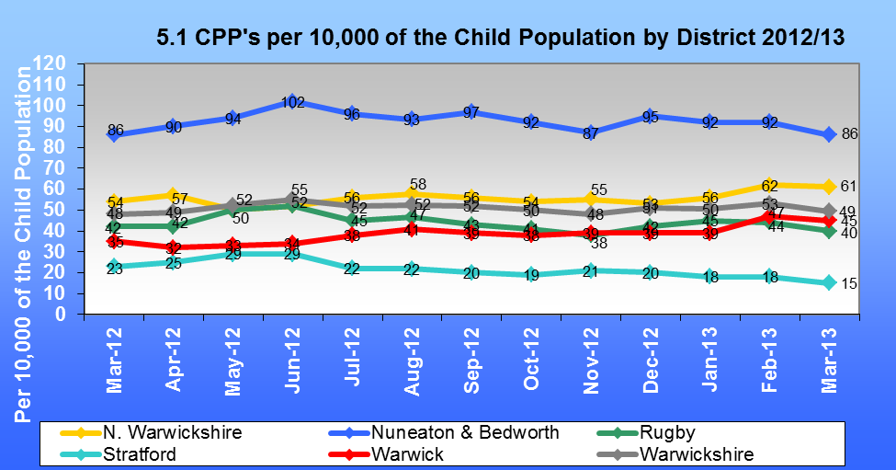

The most significant rise this year has been seen in Warwick District (up from 35 per 10,000 at 31 March 2012 to 45 per 10,000 at 31 March 2013) whilst Stratford District saw the largest decrease (down from 23 per 10,000 to 15 per 10,000). The Stratford District also saw an increase in the initiation of legal proceedings, so it may be that there has not been a fall in child protection activity overall, as once in care a child would no longer have a CP plan.

**6. Children subject to a child protection plan at 31st March**

As at 31 March 2013, 550 children were subject to a Child Protection Plan in Warwickshire. This is a 3% increase on the 534 children subject to a plan as at 31st March 2012. There has also been an increase in the number of children subject to a CP Plan who were temporarily living in the area, up from 26 as at 31 March 2012 to 45 as at 31 March 2013. Chart 6.1 shows how this number has progressed over the past three years.

**CHILDREN SUBJECT TO A CP PLAN INCLUDING THOSE TEMPORARILY LIVING IN WARWICKSHIRE**

**WARWICKSHIRE CP PLANS ONLY**

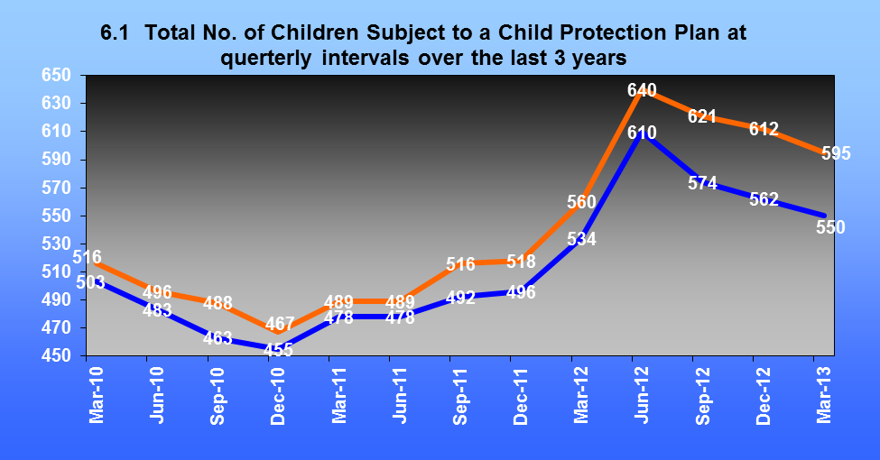

**6.2 Child Protection Plan Demographics**

|  |  |  |  |
| --- | --- | --- | --- |
|  | **31-Mar-11** | **31-Mar-12** | **31-Mar-13** |
| **Gender** |  |  |  |
| Male | 242 | 276 | 260 |
| Female | 224 | 249 | 276 |
| Unborn | 12 | 9 | 14 |
| **Age** |  |  |  |
| Unborn | 12 | 9 | 14 |
| Under 1 | 44 | 64 | 54 |
| 1 to 4 | 173 | 167 | 152 |
| 5 to 9 | 123 | 150 | 175 |
| 10 to 15 | 115 | 128 | 132 |
| 16 - 17 | 11 | 16 | 23 |
| **Ethnicity** |  |  |  |
| White British/Irish/Other | 430 | 456 | 479 |
| BME | 35 | 66 | 49 |
| Not Recorded | 1 | 3 | 8 |
| Unborn | 12 | 9 | 14 |

As at 31 March 2013, the was a higher ratio of females than males subject to a CP Plan in comparison to the national published child protection data which showed a slightly higher ratio of males to females. It is worth noting that previous years have shown a higher ratio of males in Warwickshire being subject to CP Plans. We also had a slightly higher proportion of unborn children subject to a plan than was seen in the published national child protection data for 31 March 2012.

As at 31 March 2013, the largest proportion of children subject to a Child Protection Plan in Warwickshire were those aged 5 to 9. This is a slight change on previous years when the largest proportion of children subject to plan were in the 1 to 4 age bracket. In comparison the largest age group subject to a CP plan nationally were those aged 1 to 4 which is the second largest group in Warwickshire as at 31 March 2013. It is also interesting that the largest proportion of the local Warwickshire 0-17 population are aged 10 to 15 whilst this is only the third largest age group of children subject to a CP Plan. These highlights the relative vulnerability of younger children and the importance of making timely responses to emerging need and risk for these children.

8.9% of children who are subject to a CP Plan in Warwickshire at 31 March 2013 were BME. This is slightly lower than the overall proportion of the general 0-17 population in Warwickshire that are BME (10%) but is significantly lower than the national proportion of BME children that are subject to a CP Plan (19.4%). At present there is not a comparison data set of the ethnicity of children receiving CAF and other early help services which makes it hard to explain this difference.

A commonly suggested reason for the relative over-representation of Black and Asian children in the CP population nationally is that the reach of early help services to their families is less good than for white European families, another that their families are more likely to be social dis-advantaged. The lower figure locally may reflect the particular demography of BME families in Warwickshire. The more systematic collection of ethnicity data by the CAF team which has now begun may help to answer this question.

**6.3** Chart 6.3 shows the categories under which children were subject to a Child Protection Plan as at 31st March 2013 with the previous year’s figure shown for comparison. Increases were seen this year in children under ‘Multiple’ categories, up 5.4% to 45.3%. However, slight decreases were seen in children subject to Child Protection plans under all of the individual categories.

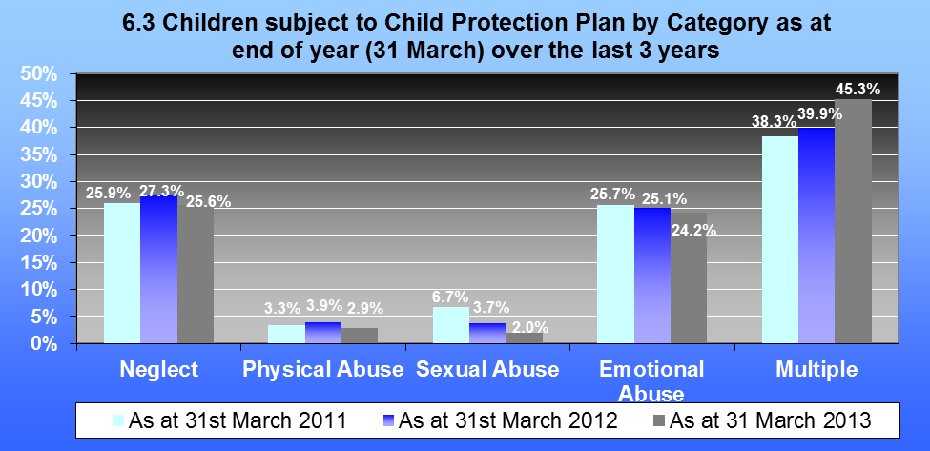

**6.4** Chart 6.4 shows children by category and age range. As at 31 March 2013, the largest number of children subject to a Child Protection Plan were those aged 5 to 9 and those aged 10 to 15 who had ‘multiple’ categories. The largest number of children under a single category though were those aged 5 to 9 for ‘emotional abuse’.

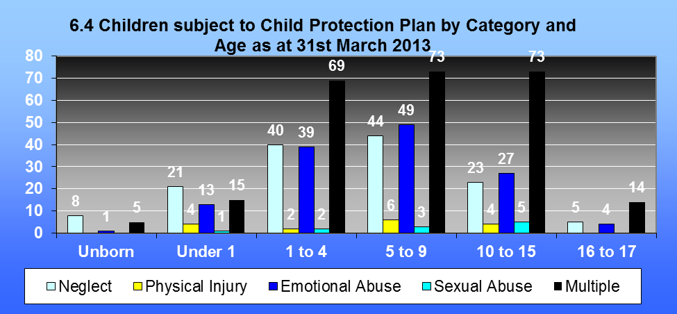

**7. Child Protection Plans Initiated during the year.**

**7.1** The majority of the 609 children made subject to a Child Protection Plan during 2012/13 were given the category of ‘Multiple’. This was followed by the categories of Neglect and Emotional Abuse. The category that has seen the biggest increase compared to last year was for those with ‘multiple’ categories whilst the biggest decrease was seen in those who had a plan initiated under the category of ‘physical abuse’. (See Chart 7.1 below).



**7.2** Of the 609 children who became subject to a Child Protection Plan during the year ending 31st March 2013, 528 (86.7%) of these became subject of a Child Protection Plan for the first time compared to 434 (83.5%) last year. A further 81 (13.3%) children became subject to a Child Protection Plan for a second or subsequent time. This is a positive decrease on last year when 86 (16.5%) of the total number (520) of children became subject to a Child Protection Plan for a second or subsequent time.

**7.3** Chart 7.3 shows the number of children who became the subject of a child protection plan for a second or subsequent time over the last three years. This chart also identifies those who became subject to a child protection plan for a second or subsequent time within less than two years of their previous plan. A longer gap between repeat plans means it is more likely to be unrelated to the original reasons for a plan, for example it could reflect a change in the composition of the household. It is positive that repeat plans over any times interval have fallen this year, and the larger fall in repeat plans shortly after the end of the previous one is an encouraging sign that work done to increase the focus of child protections plans may be having some effect.

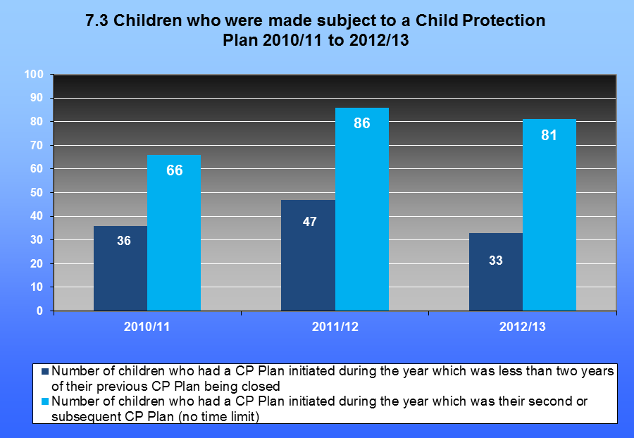

The number of children who became subject to a plan for a second or subsequent time has decreased from 86 last year to 81 this year. The number for whom a second or subsequent plan was initiated within 2 years or less of their previous plan having been closed also saw a decrease, down from 47 to 33.

**8. Duration of Child Protection Plans.**

**8.1** 590 children had their plans closed during the year ending 31st March 2013. This is an increase of 126 (27.2%) when compared with the 464 discontinued during the previous year. Chart 8.1 shows the number of children who had their Child Protection Plans closed during 2012/13, by the length of time they were subject to a Child Protection Plan at the point of closure compared to the previous 2 years.

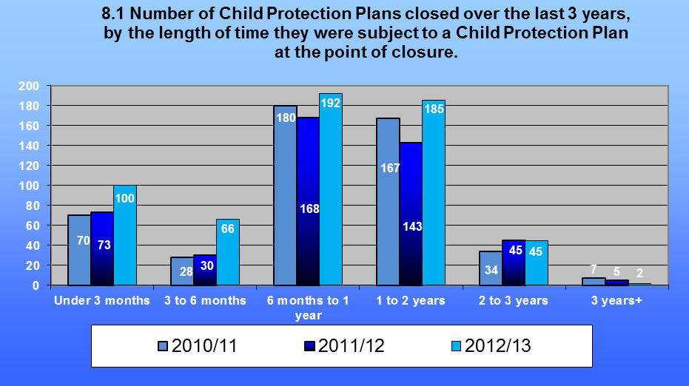

**8.2** Table 8.2 shows this year’s discontinued plans by the length of time the child was subject to a Plan as a percentage of all plans closed in the year and compares this with the previous two year’s figures.

|  |  |  |  |
| --- | --- | --- | --- |
| **8.2 Duration of Child Protection Plans Prior to Discontinuation** | | | |
|  | **2010/11** | **2011/12** | **2012/13** |
| Under 3 months | 14.4% | 15.7% | 16.9% |
| 3 months but under 6 months | 5.8% | 6.5% | 11.2% |
| 6 months but under 1 year | 37.0% | 36.2% | 32.5% |
| 1 year but under 2 years | 34.4% | 30.8% | 31.4% |
| **2 years but under 3 years** | **7.0%** | **9.7%** | **7.6%** |
| **3 years and over** | **1.4%** | **1.1%** | **0.4%** |

**8.3** Performance for Child Protection Plans lasting 2 years or more (previously national indicator NI64) was 8.0%, which is a positive decrease on last year’s figure of 10.8%. It is also pleasing that there is a fall in very long plans of more than 3 years. Plans lasting more than 2 years are reviewed under the escalation process to provide some external scrutiny of the plans for the child. This process will be developed to use the cases to learn about blockages in the system and consider ways of addressing these.

The small increase in the number of plans lasting less than 3 months is cause for concern. It is unlikely that three months is long enough for meaningful work to be accomplished, and the cost to the family of being subjected to a CP conference and all that that entails is probably greater than any benefit from such a short plan in most cases. This is likely to be another focus of work done with the Dartington SRU as there may be other ways to manage these cases more effectively.

**9. Initial Child Protection Conferences held during the year.**

**9.1** During the year ending 31st March 2013 there were 676 children subject of an Initial Child Protection Conference. This represents an 11.6% increase on last year when 606 Children were subject to an Initial Child Protection Conference. Of the 676 Children subject to a conference held during 2012/13:

* 627 children (92.8%) were subject to an Initial Conference that took place within 15 working days of initiation of the S.47 Enquiry
* 609 (90.1%) resulted in the initiation of Child Protection Plans.

|  |  |  |  |
| --- | --- | --- | --- |
|  | **2010/11** | **2011/12** | **2012/13** |
| Number of Children subject to an Initial CP Conference during the year | 536 | 606 | 676 |
| Number of children whose initial child protection conferences were held within 15 working days of the initiation of the s.47 enquiries which led to the conference | 517/536 = 96.4% | 574/606 = 94.7% | 627/676=92.8% |
| Total number of CP Plans initiated during the year following an Initial Child Protection Conference | 459/536=85.6% | 520/606=85.8% | 609/676=90.1% |

The fall in the number of initial conferences held within 15 days of the s.47 enquiry beginning demonstrates the strain that is experienced by the whole system, and in particular the review unit, by the continuing rise in child protection activity.

**10. Reviews of Child Protection**

**10.1** During the year ending 31st March 2013, 421 children had been subject to a plan continuously for at least three months. Of that 421, 415 (98.6%) had been reviewed within timescales. This is a slight decrease on last year when 100% was achieved. Again, this is a statistical demonstration of the difficulty for the system in absorbing the increase in demand.

|  |  |  |  |
| --- | --- | --- | --- |
|  | **31-Mar-11** | **31-Mar-12** | **31-Mar-13** |
| **Children subject to a plan continuously for at least three months who were reviewed within timescales** | 354/357=99.2% | 409/409=100% | 415/421=98.6% |

**11. Summary of Child Protection Activity.**

**11.1** The chart below summarises some of the activity detailed in Sections 3-9.

**Warwickshire’s**

**0 – 17**

**Child Population**

**111,913**

**CAFS initiated**

**653**

**Referrals received**

**6524**

**Initial Assessments undertaken 3525**

**3525**

**Child in Need Plan started lasting 2 months or more**

**1982**

**Children subject to a Child Protection Conference during the Year 676**

**676**

**Child Protection Plans Initiated 609**

**550**

**Children were Subject to a Child Protection Plan within Warwickshire as at 31st March 2013**

**12. Number of Private Fostering arrangements.**

**12.1** A privately fostered child is defined as a child under the age of 16 (18 if disabled) that is cared for by someone other than a close relative (i.e. a grandparent, brother, sister, uncle, aunt, or step-parent). A child is not privately fostered if the person caring for him or her has done so for fewer than 28 days and does not intend to do so for longer than that. Privately fostered children are not “looked after” children in the terms of section 22 of the Children Act 1989. However, Local Authorities have a responsibility to ensure that the welfare of privately fostered children is promoted, as identified in Part IX of the Children Act 1989, amended by section 44 of the Children Act 2004.

|  |  |  |  |
| --- | --- | --- | --- |
|  | 2010/11 | 2011/12 | 2012/13 |
| The number of notifications of new private fostering arrangements received during the year | 12 | 9 | 12 |
| Number of new arrangements that began during the year | 12 | 8 | 11 |
| Number of private fostering arrangements that ended during the year | 18 | 11 | 11 |
| **Number of children under private fostering arrangements as at year end (31 March)** | **7** | **4** | **4** |

**7. Business Plan for 2013-2014**

|  |  |  |  |
| --- | --- | --- | --- |
| Action Required | By Whom | Complete by | Reason for Action and  Outcomes Required |
| **A. Create and Maintain a Learning System**  *Actions continuing from workplan 2012-2013*:  Hold 10th Annual Conference – theme to be Child Sexual Exploitation.  Participate in 2nd cycle of Munro Development Demonstrator sites  Undertake analysis of accumulated CDOP data  Develop links with Warwickshire Children in Care Council  Monitor application in Warwickshire of the | Strategy and Communications subcommittee  .  Performance, Monitoring and Evaluation sub-committee  CDOP Manager  Performance, Monitoring and Evaluation sub-committee  .  Chairs group | December 2013  March 2014  September 2013  December 2013  November 2013 | Share work being done, promote understanding of concepts underpinning our strategy, learn from others who are more advanced in their development of these services.  Share our learning with others, and learn from other LSCBs.  Maximise opportunity to prevent child deaths by addressing modifiable factors.  To build the experience of children and young people into our assessment of the effectiveness of safeguarding services, to promote the development of services which children and young people experience positively.  To understand whether social workers |
| Action Required | By Whom | Complete by | Reason for Action and Outcomes Required |
| Professional Capabilities Framework for social workers  Agree processes for ensuring integration of learning from SCRs held in other areas into WSCB work plan  Nominate individuals who sit on both Health and Wellbeing Board and WSCB to act as a link between the two Boards, and to provide regular bi-lateral feedback | Special Cases  Chair of WSCB and Chair of H and WB Board | December 2013  December 2013 | are being equipped to provide leadership to inter-agency safeguarding work.  To inform service development in Warwickshire  To promote mutual understanding of the roles of the two Boards and to facilitate bi-lateral communication, to promote the alignment of priorities between the two Boards. |
| *Actions arising out of Learning and Review Activities*:  Complete training needs analysis, and enquiry into the reasons for reducing attendance, and develop new training programme accordingly | Inter-agency Training Officer; | November 2013 | To ensure training offered by WSCB is useful, accessed by the right staff, and results in better safeguarding practice on the front line. |
| **B. Strengthen Accountabilities**  *Actions continuing from work plan 2012-2013*:  Implement scrutiny of agencies’ own audits as set out in Performance | Performance, Monitoring and Evaluation sub-committee- | March 2014 | Inform judgements about the effectiveness of safeguarding practice |
| Action Required | By Whom | Complete by | Reason for Action and Outcomes Required |
| Monitoring Framework  Implement use of reviews of cases with extended CP plans under the escalation process to learn about functioning of the CP system, as set out in the Performance Monitoring Framework  Complete s.11 Audit and provide feedback to agencies on proposed action plans; monitor implementation of these  Monitor the roll out of services in the new SARC and seek information from the SARC about the arrangements for safeguarding children and young people  Complete ‘Health Check’ of WSCB’s own  Functioning  Develop new data set for use in annual report  Develop WSCB approach to assessing | Performance, Monitoring and Evaluation sub-committee  Performance, Monitoring and Evaluation sub-committee  Designated doctor and nurse and Development Manager  Strategy and Communications sub  committee  Development Manager with Performance, Monitoring and Evaluation sub-committee  Strategy and Communication sub- | Ongoing, to March 2014  March 2014  September 2013  September2013  March 2014  February 2014 | To identify blockages or complications in the system which may be hampering practitioners from performing well.  Understand where improvements are needed to ensure children are being safeguarded, to provide oversight of improvement plans  On behalf of WSCB; ensure that the arrangements for children in the service meet their safeguarding needs holistically  Understand where WSCB needs to  improve its own performance  Better understand the effectiveness of safeguarding activity  Provide a framework for understanding |
| Action Required | By Whom | Complete by | Reason for Action and Outcomes Required |
| ‘Early help’.  *Actions arising out of learning and review activities*:  Request update information about agency action plans following inspection recommendations: Probation, Youth Justice.  Undertake audit of Deaf children’s services  Feed into the action plan for the ‘Think Family’ Board, and request regular feedback on the progress of this work  Commission multi-agency audit to investigate repeat child protection plans  Seek feedback on investigation being conducted as part of the work with Dartington SRU on the effectiveness of ‘step down’ arrangements at the end of a | committee  WSCB  Performance, Monitoring and Evaluation sub-committee  WSCB members who sit on Think Family Board  Performance, Monitoring and Evaluation sub-committee  Performance, Monitoring and Evaluation sub-committee | April 1013  February 2014  Ongoing until March 2014  December 2013  Ongoing until conclusion of the project in March 2014 | the effectiveness of services  Ensure learning is put into practice and outcomes for children and young people improved  WSCB understand whether the particular safeguarding needs of deaf children are recognised and addressed  Promote and support effective safeguarding of children whose parents have mental health, drug and substance misuse difficulties  Better understand causes of repeat plans, identify changes that could be made to CP plans to increase their effectiveness  Better understand functioning of safeguarding system, identify areas of weakness that need to be addressed |
| Action Required | By Whom | Complete by | Reason for Action and Outcomes Required |
| CP plan  Develop a framework to support partners  undertake audit in respect of the DfE Children’s Safeguarding Performance Framework question L10, and request this audit be undertaken. (‘How do you know whether children and parents/carers feel that referrals were made at the right time, for the right reasons, by the right agencies?’  Develop a new training course supporting staff to make and receive referrals for child in need and child protection services, incorporating an understanding of Warwickshire’s Thresholds statement and Escalation procedure. | Performance, Monitoring and Evaluation sub-committee  Inter-agency Training Officer | March 2014  March 2014 | To inform the development of service delivery which is appropriately offered to parents and carers and to children and young people in a way which maximises the likely effectiveness.  Promote understanding of the Thresholds document and Escalation Procedure, improve timely response to families in need. |
| *Actions arising out of the revised statutory guidance ‘Working Together’:*  Draw up ‘Learning and Improvement’ Framework  Make a formal link with the JSNA steering | Special cases sub-committee  Strategy and Communications sub- | December 2013  December 2013 | Required by WT 2013-08-01, ensure that learning and audit activities result in improvement  Required by WT 2013, ensure that |

|  |  |  |  |
| --- | --- | --- | --- |
| Action Required | By Whom | Complete by | Reason for Action and Outcomes Required |
| group by giving a member of this group who sits on WSCB the responsibility represent WSCB’s concerns to the JSNA, and feedback JSNA learning to the Board; review the effectiveness of this arrangement.  Make formal links with the Health and Well Being Board by giving a member of this Board who sits on WSCB the responsibility provide feedback to each Board about the work of the other; review the effectiveness of this arrangement  Develop a WSCB Training strategy setting out the training staff working with children should receive, and whether this should be single agency or multi-agency.  Request information from Coventry and Rugby CCG about their enquiries into how Health provider trusts are satisfying themselves that designated staff for child protection have sufficient time, funding, supervision and support to carry out their safeguarding duties | committee  Strategy and Communications sub-committee  Training sub-committee  Health sub-committee on behalf of WSCB | December 2013  February 2014  February 2104 | WSCB bases its work on needs assessment done by the JNSA, and that need identified by WSCB is fed back to the JSNA for consideration by the Health and Wellbeing Board and Children’s trust  Ensure work strands of each Board reflect the knowledge and work of the other  Required by WT 2013, ensure that partners are clear what is expected of them with regard to the provision of training for staff, ensure practitioners have the knowledge and confidence needed for good safeguarding practice.  For WSCB to be satisfied that this statutory requirement is being met |
| Action Required | By Whom | Complete by | Reason for Action and Outcomes Required |
| Review arrangements for appointing, and reviewing the appointment of the independent chair | Chair’s sub-committee with WCC Chief Exec | December 2014 | To put in place arrangements in Warwickshire which comply with statutory requirements, to ensure that WSCB enjoys strong leadership and is able to carry out its responsibilities to a high standard |
| **C Promote Effective Practice**  *Actions continuing from 2012-2013*  Complete the update of Inter-agency safeguarding procedures.  Monitor the contribution and function of the Principle Social Worker in WCC  Form a CSE sub-committee  Convene Safer recruitment task and finish group when new LADO in post (expected  to be September) | Systems and Procedures sub-committee.  Chairs group  Development Manager  LADO and representatives of partner agencies | December 2013  November 2013  September 2013  November 2013 | Provide staff in Warwickshire with clear and helpful procedures and guidance which support effective safeguarding practice  Promote and support effective children’s social work practice  Ensure CSE strategy is implemented, and kept under review in recruitment  To support compliance with statutory guidance, to ensure recruitment practices keep children safe |

|  |  |  |  |
| --- | --- | --- | --- |
| Action Required | By Whom | Complete by | Reason for Action and Outcomes Required |
| *Actions arising out of learning and review*  Provide joint training for adult’s and children’s practitioners to ensure that needs arising for children as a result of parents’ mental health and drug problems are understood, assessed and met  Contribute to, and support the implementation of the Warwickshire ‘Violence against women and girls’ strategy | Inter-agency Training Officer and Training subcommittee  Strategy and Communications sub-committee other individuals as appropriate | March 2014  March  2014 | Support “Think Family” protocol and promote effective partnership working  To contribute to the development of an effective and useful strategy, to reduce violence against women and girls in Warwickshire, to reduce the number of children living in households where domestic abuse is a feature. |
| Develop a ‘Neglect’ strategy  Re-develop the WSCB website, including material for parents and children as well as | Strategy and Communications sub-committee  WSCB team with Strategy and Communications sub-committee | December 2014  January 2014 | To provide a coherent response to the issues uncovered in case reviews, to increase the effectiveness of responses in Warwickshire to chronic deficits in parenting capacity across the safeguarding continuum, to reduce the harm done to children caused by drift in the management of their services  Provide one easy point of access to procedures, strategies, policies and |
| Action Required | By Whom | Complete by | Reason for Action and Outcomes Required |
| professionals  *Actions arising out the revised statutory guidance ’Working Together’*  Develop procedures for single social work assessment of children in need  Develop protocols for assessment  Review ‘Threshold for Intervention’ Document to address requirements of new guidance  Publish Information sharing protocol | Social Care  Social Care and Systems and Procedures sub-committee  Social Care and Systems and Procedures sub-committee  Systems and Procedures sub- | March 2014  July 2013  September 2013  December 2013 | forms used in inter-agency children’s safeguarding in Warwickshire, to provide  information about the Board to staff and the public, to provide information about  children’s safeguarding services, and sources of information and support to children, young people and their parents and carers  Required by WT 2013, remove the distinction between initial and core assessments  Required by WT2013,Provide clarity for referrers about what to expect when a referral is accepted by Social Care  WT 2013 includes requirement to define threshold for s.20 accommodation and s.31 application for a care order, to support inter-agency dialogue about the appropriate level of intervention for a family at a particular point in time.  Support agencies in balancing the |
| Action Required | By Whom | Complete by | Reason for Action and Outcomes Required |
|  | committee in co-operation with the  Safer Communities partnership |  | requirements of data protection/ confidentiality and co-operation to promote good safeguarding practice. |
| **D Promotion of Early Help**  *Actions continuing from 2012-2013*  Request information about the WCC Early Help and support strategy    Participate in the second phase of the work WCC is undertaking with Dartington SRU to use evidence based approaches to prevent children from needing CP plans.  *Actions arising out the revised statutory guidance ‘Working Together’*  Develop WSCB processes for assessing the effectiveness early help. | WCC and partners as requested  WCC and partners as requested  Strategy and Communication sub-committee; | July 2013  March 2014  February 2014 | To assist WSCB with making an assessment about the effectiveness of Early Help services  To safely reduce the number of children in Warwickshire with child protection plans, reduce the number of children experiencing significant harm.  Required by WT 2013, reduce the number of children requiring services at tiers 3 and 4, reduce the number of children experiencing significant harm. |