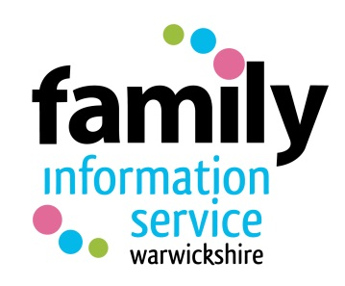
Family Information Service Referral Form

The Family Information Service can provide a wide range of information/support/ referrals for families in Warwickshire either via our helpline or on a face to face basis.
FIS Brokerage Service is a 1:1 early intervention service which can be used to support families with children age 0 to 25 living in Warwickshire to access services where there are barriers and/or complex needs.
To access the service please send the completed form to the FIS e-mail address where this will be triaged by the helpline and sent to Brokerage should 1:1 support be required to meet the family needs. Any parental enquires to be directed to the FIS Helpline 01926 742 274.
Important note if you are requesting support for goods / grants, please be aware:-
- that prior to making applications for grants an income and expenditure will need to be completed to establish need
- there are no guarantees goods will be awarded
- the process often takes 6 – 8 weeks

Requests for Family Support Workers should be made by using the form on the Children and Families pages on the Warwickshire County Council website.
Date:
Referrer’s Name: | Contact Tel No:
Email:
Organisation:
Client’s Personal Information
Parent/Carer Name:  Child/Children’s name: | Email:
Mosaic number (if known):
Telephone: | Mobile:
Address:

Please give details of assistance required (tick all that apply)

DLA/PIP form ☐
Housing Support ☐
Childcare ☐
Finances ☐
SEND ☐
Breakthrough ☐
Other (please add details):

Please identify barrier to accessing services if appropriate (tick all that apply)

Mental health ☐
Disability ☐
Language ☐
Low income ☐
Crisis point ☐
Other (please add details): ___________________________________

Additional Information:
(this should include any relevant background information/family circumstances)

Identify any presenting risks i.e. lone working:

Please can you confirm the client has given consent for this referral:

Referrals WILL NOT be progressed without all the requested information
Please e-mail the completed referral form to fis@warwickshire.gov.uk and make the family aware FIS will call from a withheld number - 3 attempts will be made to make contact.
Once the FIS Officer/Brokerage Officer has completed their interventions with the family, correspondence will be sent to the referrer advising of action taken.
