**New Chaperone Application Pack**

**Contents Page**



Chaperone Application Process Explained 2

Chaperone Application Form 3-7

Chaperone Code of Conduct 8-11

Payment Information 12

DBS Information 13-14

ID documents for DBS 15-17

DBS update service 19

Training NS170 and NS490 - Safeguarding e-learning 20-23

**Chaperone Application Process Explained**

Thank you for applying to become an approved chaperone with Warwickshire County Council. Below explains the process of becoming an approved chaperone, please read this carefully. **We are unable to process Chaperone applications for anyone who lives outside of Warwickshire. Please apply directly to the local authority in which you live in.**

You will be required to email in the following documents to [chaperones@warwickshire.gov.uk](mailto:chaperones@warwickshire.gov.uk) at the beginning of the application process. We are unable to process your application without receiving the following:

* Chaperone application form
* 3 forms of **original** ID (Please see the attached form regarding the forms of ID we will accept)
* A headshot photo for your chaperone badge
* Screenshots of the two training certificates following the completion of the training modules.
* Confirmation that payment has been made to us (£25 for volunteer chaperones or £69 for chaperones undertaking paid work).

Once we have received the above documents via email, we will contact you to arrange for you to attend either **Shire Hall, Warwick** or **Kings House, Bedworth** to attend an ID check for your DBS application. Prior to this ID check you will be required to complete the DBS online application, instructions for this are below, titled **‘Online DBS Link’.**

You will be required to bring with you the 3 forms of ID you emailed in. These need to be **original** copies and not copies that have been printed at home. The ID check will take no longer than **15 minutes.** Once this ID check has taken place, the Business Support Officer who conducted your ID check will then process your DBS application that same day. It has been known for DBS applications to take up to four months, but most of them do return quicker than this.

**If you are on the DBS updates service**

If you have subscribed to the DBS updates service and your DBS is enhanced and for working with children, we may be able to accept this, instead of you having to re-do another DBS. Please forward to us your DBS on email, we will then check to see that we can locate you on the updates service and then will only need to view your DBS certificate. If you are on the updates but we are unable to locate you for whatever reason, you will need to do a new DBS.

Following your ID check, you will then be contacted to arrange a convenient date and time for a Chaperone Interview, which will take place via Microsoft Teams. Please ensure you have downloaded the Microsoft Teams app **ahead of the interview.** The interview will last no longer than 30 minutes. Following a successful interview, we will then complete a Social Care check to ensure that there are no concerns logged regarding the applicant working with children. Once the DBS has returned and satisfactory references have been received, we then create the Chaperone Badge and send this to our post room. They require **5 working days** to get this posted out.

**NEW CHAPERONE APPLICATION FORM**

***CHILDREN IN ENTERTAINMENT***

**Please complete this form in CAPITALS**

|  |  |
| --- | --- |
| **SURNAME**  **(Miss, Mrs, Ms, Mr)** |  |
| **FORENAME** |  |
| **PREVIOUS SURNAME (IF APPLICABLE)** |  |
| **DATE OF BIRTH** |  |
| **CURRENT ADDRESS** |  |
| **POSTCODE** |  |
| **PREVIOUS ADDRESS IF LIVING AT THE ABOVE ADDRESS LESS THAN 5 YEARS** |  |
| **NAME OF THEATRE/DANCE SCHOOL/ORGANISATION** |  |
| **PHONE NUMBER** |  |
| **EMAIL ADDRESS** |  |

**Do you have any children? Yes / No**

**If yes, and your children are under 18 years old, please confirm:**

|  |  |  |  |
| --- | --- | --- | --- |
| **First name** | **Surname** | **DOB** | **School name** |
|  |  |  |  |

**Current/most recent employer:**

|  |  |
| --- | --- |
| **Name** |  |
| **Address** |  |
| **Postcode** |  |
| **From and to dates** |  |
| **Nature of work** |  |

**Please give any details of any relevant experience you have working with children *(including teaching, social work, youth work, childminding, nanny, playgroups, nursery nurse, Cubs/Brownies)* and anything else which may support this application (**continue on a separate sheet if necessary)

|  |
| --- |
|  |

**If approved, will you be acting as a chaperone in a volunteer or professional (paid) capacity? Please tick appropriately:**

|  |  |
| --- | --- |
| **Volunteer Chaperone** |  |
| **Paid Chaperone** |  |

**Do you have a health condition that might have a bearing on your application?**

|  |  |
| --- | --- |
| **No** |  |
| **Yes – please give details** |  |

**References**

**Please provide details of two responsible persons who will be prepared to give you references as to your suitability to be a chaperone. References should be from separate sources and not from the same organisation or employer. At least one of these should know you in a professional capacity. Please state in what capacity the person is known to you. You must have known them for at least two years and they must not be from a spouse, partner or family relation or from someone with whom you live.**

|  |  |
| --- | --- |
| **1st Referee’s title and name:** |  |
| **Telephone number:** |  |
| **Capacity known to you:** |  |
| **Email address:** |  |

|  |  |
| --- | --- |
| **2nd Referee’s title and name:** |  |
| **Telephone number:** |  |
| **Capacity known to you:** |  |
| **Email address:** |  |

**Due to the nature of the work, we need to know if you have ever been convicted of a criminal offence, (including traffic offences) or had an allegation made against you, or been the subject of a child protection case conference.**

***Please tick the appropriate box and provide relevant details:***

|  |  |  |  |
| --- | --- | --- | --- |
| **I have not** been convicted of any offences. |  | **I have not** had an allegation made against  me or been the subject of a child protection  case conference. |  |
| **I have** been convicted of the offences shown  below: |  | **I have** had an allegation made against  me / been the subject of a child protection  case conference, as noted below: |  |

|  |  |  |  |
| --- | --- | --- | --- |
| **Date(s)** | **Court/Authority** | **Offence/Allegation** | **Outcome** |
|  |  |  |  |

**We also need to know if you have ever received a reprimand, final warning or a caution.**

|  |  |  |
| --- | --- | --- |
| Please complete the following if applicable: | **Name of offence** | **Date of offence** |
| **Reprimand** |  |  |
| **Final warning** |  |  |
| **Caution** |  |  |

**DECLARATION TO BE SIGNED BY APPLICANT**

I hereby declare that the above information is true, to the best of my knowledge. I understand that I will be liable to prosecution if I have wilfully stated anything which I know to be false, or do not believe to be true.

I understand that any application will be subject to satisfactory references, assessments and criminal record checks. Any misleading statement or deliberate omission may disqualify my application.

I am aware that the necessary enquiries and checks will be undertaken by Warwickshire County Council in order to confirm that the information included in this application form is correct, to verify the authenticity of my qualifications, and to check whether I have any relevant criminal record which might deem me unsuitable for the role of chaperone. I am aware that I will need to attend for an interview as part of this application. I declare that I will notify Warwickshire County Council of any change of name or address, or any change in circumstances that may affect my ability to effectively carry out duties and responsibilities of a chaperone.

**I confirm I am a paid / volunteer chaperone *(please delete accordingly).***

**I confirm I have read, understood and agree with the Chaperone Code of Conduct.**

|  |  |
| --- | --- |
| **Signed** | **Dated** |
|  |  |

**I would like to be on the public list and agree for my information to be shared with agencies who are seeking to recruit chaperones for paid work. YES/NO.**

**This form must be sent on email with all below, and confirmation that you have made the payment via BACS:**

|  |  |
| --- | --- |
| Payment – use the BACS information attached to this email |  |
| Photo to be emailed |  |
| Completed Chaperone Application Form |  |
| 2 x Safeguarding Training Certificates (online training) |  |
| 3 forms of identification, as listed when submitting the DBS  *This must include a passport and driving licence (if you have these) plus one other form of ID.* |  |
| **I confirm:** Online completion of my DBS |  |
| **I confirm:** Online completion of 2 x Safeguarding TrainingCourses |  |

**If I decide to join the updates scheme for my DBS, I agree to my records being checked. Yes/No**

**Please contact our office to arrange for the ID check and interview, the ID check will need to be in person, email as below.**

**Please email this form to us, do not post to us.**

Tel: (01926) 742522 Email: chaperones@warwickshire.gov.uk

**PLEASE NOTE: If you choose to email us, you may be emailing from an account that is not secure, we cannot guarantee it can be kept secure whilst it is being sent to us.**

***If you do not receive your chaperone badge within 2 months of submitting this form to us,***

***please contact us on the telephone number above to check progress.***

***Your information rights*** *To see how we use your personal data and what your information rights are, please read our overall customer privacy notice at www.warwickshire.gov.uk/privacy which includes the contact details if you have a complaint about your information rights. For general**enquiries, contact Warwickshire County Council customer services on 01926 410410*

**Chaperone Code of Conduct**

The Chaperone’s first duty is to the children in their care. They must ensure the safeguarding and welfare of the children at all times. While they are engaged as the Chaperone on a production, they may not undertake any other activity that would interfere with their duties. The chaperone is acting in loco parentis, except when the child is being taught by an approved teacher, and should exercise the care, which a good parent might reasonably be expected to give.

Chaperones are responsible for the welfare of the child/children in their care at all times during the period, beginning with the first and ending with the last performance to which the licence relates, except where the child is in the care of their own parent or teacher.

* A chaperone must be aware of and understand the conditions of the performance licence of the child who is in their care.
* A chaperone is the key person who the children look to for guidance, protection, clarification, and support. Chaperones must make themselves aware of any medical needs/disabilities of the children in their care and be clear about any arrangements relating to medicines e.g. inhalers, care of children with an allergy or diabetes or any assistance the child may need.
* A chaperone should know where the children in their care are at all times. A chaperone is allowed to be in charge of a maximum of 12 children any one time. However, this may be dependent upon the ages and the needs of the children and the ability to have the children in sight at all times. If the chaperone considers they cannot look after the number of children in their care safely, you must advise the person in charge of the production to change the arrangement.
* A chaperone must not permit young people under statutory school age (last Friday in June in the school year in which they are 16) to leave the performance/rehearsal venue unescorted, unless in the company of their parents.
* Always be aware of the fire/safety/major incident arrangements of the venue. A chaperone should be aware of the first aid procedures at the venue.
* A chaperone should ensure that any/all accidents/incidents are reported and recorded.
* A chaperone must ensure that the children are comfortable. Ensure that the children have sufficient access to food and drink and be aware of any allergies the child has, have the appropriate mealtimes and rest/comfort breaks.
* Ensure all the young people have adequate and appropriate supervision during changing and toilet arrangements (where possible children should be allocated separate toilets from the adults).
* A chaperone should always keep a register of all the young people in their care and keep the daily record sheets up to date. Head counts alone are not acceptable.
* Chaperones must stand up for the child above production pressures.
* Chaperones must keep a confidential list of all important contacts e.g. the child’s licencing authority, the local authority in whose area the child is performing, the child’s parent/legal guardian, contact details, any medical details etc.
* Chaperones should be familiar with the production’s social media policies.
* All chaperones must work within the agreed parameters of confidentiality e.g. sharing of personal information/details must only be disclosed on a need to know basis, to the appropriate people.
* A chaperone must safeguard the sharing of information to ensure that it is not accessed by third parties and must not release any child’s details to any members of the public/press/media.

**Behaviour of Chaperones**

As a chaperone you must:

* Be the child’s champion.
* Conduct yourselves in an appropriate manner on set. You should be visible so the young people can see you, but not get in the way of the crew/set.
* Be alert to potential hazards and ensure that your focus always remains on the young people.
* Always pay attention to the welfare of the children and not be distracted in any way such as by being ‘star struck’, reading, using social media etc.
* Always report to the head chaperone or other identified appropriate person if any problems or queries arise. Report any concerns immediately.
* Know who to report them to and what to do in each case.
* Be aware that some children are in the care of their parent whilst on set. A chaperone should intervene if a parent agrees to something that may contravene child performance regulations or may endanger a child.
* Ensure your DBS check is renewed either annually via the update service or every three years.
* Ensure that you comply with any conditions to ensure your chaperone approval is renewed.
* To carry a copy of their chaperone approval when you are on a production and show this to any inspecting officer from a local authority.
* **Notify the local authority at the earliest opportunity if there are any changes in your circumstances, including health issues, arrests, and bail conditions and or safeguarding concerns relating to you or your immediate family members.**
* **Notify the local authority if you have been dismissed from a production because of concerns about your practice.**

**As a Chaperone you must not:**

* Leave the children alone with another adult (unless it is another licenced chaperone, the child’s parent, or teacher).
* Release children to an adult they are not expecting at the end of the production unless this has been confirmed by the parent / production.
* Engage in an inappropriate relationship with a child or young person. This includes communication via social media, text messaging (unless agreed in advance with parents), websites and social networking sites such as Facebook, Twitter, Instagram, and Snapchat. This means that chaperones should ensure that their personal social networking sites are set to private and children/young people are not listed as approved contacts. Equally, chaperones should not accept ‘friend requests’ from children/young people they are looking after.
* Take photos of the children.
* Use mobile phones whilst looking after the children.
* Give gifts or show favouritism to children.
* Drink alcohol and/or take drugs when you are working. Your capacity to perform your duties as a chaperone must not be impaired by alcohol or drugs.
* Possess, take, or supply illegal drugs, including cigarettes.
* Swear or use inappropriate language.
* Enter conversations of an inappropriate or sexual nature.
* Disclose or provide your personal details or information to the child.
* Permit young people to use inappropriate language. If this does happen it is important to discuss with the parents.
* Discipline the child/ren. It is not the role of the chaperone to discipline a child and they must never hit, shout, or otherwise punish a child. Any behaviour issues should be discussed with a parent, person in charge and a suitable resolution found.
* Approach cast members for autographs or photos during working hours.
* Let children perform if they are unwell.

**Physical touch**

Always check that it is ok with the child before you help them. Touch should always be conducted in an open manner. It should never be ‘secret’ or in a surreptitious manner.

**Response to disclosures:**

If a child confides in you that abuse has taken place:

* Remain calm and in control, but do not delay in taking action.
* Listen carefully to what is being said. Allow the child to tell you at their own pace and ask questions only for clarification.
* Don’t ask leading questions, use the following strategy:

T – Tell me

E – Explain that to me

D – Describe that to me

* Do not promise to keep it a secret or confidential, reassure the child that they did the right thing telling someone and explain what you will do next.
* Use the first opportunity you have to share the information you have with the Designated Safeguarding Lead (the person responsible for child protection). Each production company should have a nominated child protection person. If that person is not available, contact Children’s Social Care or the Police. You can also seek advice from the Child Employment Officer at Warwickshire County Council during working hours or from the emergency out of hours safeguarding duty team.
* As soon as possible, make some notes (using the child’s own words). Note the date, time, any names that were involved or mentioned and whom you gave the information to.
* Parents should not routinely be informed at this point if they are the subject of the disclosure as this may compromise the safety of the child.
* Where another registered chaperone is the alleged abuser, the matter must also be referred immediately to the safeguarding lead on the production who can make a referral to the appropriate licencing authority. The chaperone can prompt the production company to ensure this is done.
* Information/ evidence gathering is not the responsibility of the chaperone. This is a matter solely for the investigating authorities.

**If you have any concerns relating to the safeguarding & welfare of the child, for example neglect, engaging in inappropriate contact with adults, child sexual exploitation, it is your responsibility to inform the Designated Safeguarding Lead and to inform your local authority of any concerns.**

**Confirmation of Receipt and Understanding of the Chaperone Code of Conduct**

As an approved chaperone with Warwickshire County Council, you are expected to read, understand, and accept this Code of Conduct.

Failure to adhere to this Code of Conduct could lead to your approval being suspended and or revoked in line with the Chaperone Approval Policy.

For more information, visit the Children and Families Front Door. If you have a safeguarding concern about a child or young person and want to speak to someone call (01926) 414144 or email <https://www.warwickshire.gov.uk/childrens-social-care>.

The Children and Families Front Door operating times are: 8.30am-5.30pm Monday-Thursday, and 8.30am-5.00pm on Friday.

Outside of office hours, for an immediate concern about a child in danger, dial 999 and contact the Emergency Duty Team on (01926) 886922.

If you require any further information, please contact us on (01926) 742522 or via email: [chaperones@warwickshire.gov.uk](mailto:chaperones@warwickshire.gov.uk)

Child Employment and Children in Entertainment Team (produced November 2023)

Warwickshire County Council

**Payment Information**

BACS:

Payment for chaperones must be made by BACS.

£25 For Volunteer Chaperone

£69 For Paid Chaperone

If you are on the DBS Update Service the charge will just be £25 as we do not need to apply for a new DBS.

The person who makes the payment needs to quote **CHAPERONES and the name on the chaperone application form** when making the payment. They also need to let us know once a payment has been made, who for and for how much so we can locate it.

**Please ensure you send an email stating how much you have paid, and for which chaperone as soon as it has been paid.**

Bank details: Lloyds TSB

Account Name Warwickshire County Council

Account Sort Code 30-00-02

Account Number 01045348

Branch Address City Office,

Bailey Drive

Gillingham Business Park

Kent

ME8 0LS

Please note: **Any money paid is non-refundable** **after 6 months.**

**DBS Information**

You should now be able to login and se the on-line DBS application. If you require any help with the set up please don't hesitate to contact the DBS team on 0845 155 0982.

It is important that you follow the guidance below.

**Guidance For Applicants**

Dear Applicant

Please use the following web address to access the page for an online DBS check

[https://www.matrixscreening.com/warwickshire/applicantLogin.do?applicationType=dbs](https://eur02.safelinks.protection.outlook.com/?url=https%3A%2F%2Fwww.matrixscreening.com%2Fwarwickshire%2FapplicantLogin.do%3FapplicationType%3Ddbs&data=05%7C02%7Cchaperones%40warwickshire.gov.uk%7C463413a1b23942ed176308dc975d282c%7C88b0aa0659274bbba89389cc2713ac82%7C0%7C0%7C638551673556965814%7CUnknown%7CTWFpbGZsb3d8eyJWIjoiMC4wLjAwMDAiLCJQIjoiV2luMzIiLCJBTiI6Ik1haWwiLCJXVCI6Mn0%3D%7C0%7C%7C%7C&sdata=N7e217KTNqvsKoMUYmDQs7rMBWJRWvcYqgHRYiJyWGM%3D&reserved=0)- - please enter the website address directly into the address bar and **not** the search engine e.g. Google, to ensure you are using the correct page. Then click **Standard/Enhanced DBS Application** and **Start Application**. 

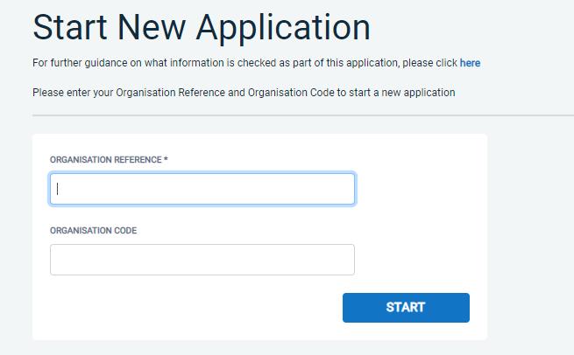

Organisation reference: CHAPERONES

Password: **W**arwick**01**

**Start application**.

Please see below your **Organisation Reference & Password** . You should not pass this onto others unless they want to apply for a DBS on-line:

* Organisation Reference: **CHAPERONES**
* Password: **Warwick01**

As you now have the option of signing up to the DBS updates, which means you may not have to, in future, apply for a DBS for each volunteer position you undertake, you need to sign up for this as part of your new DBS application. See further information regarding the DBS Update at the end of this document if you are interested in this.

Once you have completed your on-line DBS application, please double check that your name is correct, including any middle names. Due to using auto-fill sometimes it picks up your name twice. This could delay your application if not correct when submitted. Once you are confident the form is correct and you have submitted it, please contact us at chaperones@warwickshire.gov.uk to make arrangements for your ID documents to be checked. These are currently taking place in our Warwick and Bedworth offices in person. You must email your ID to [chaperones@warwickshire.gov.uk](mailto:chaperones@warwickshire.gov.uk) to ensure we have this before we undertake the interview/ID check.

Please ensure you keep the organisation reference and Password safe.

If you have any questions or require assistance please do contact us.

Kind Regards

Vetting Services Team  
Human Resources  
Warwickshire County Council  
Tel: 0845 155 0982 & 01926 418264

**ID documents for DBS**

**Documents the applicant MUST provide**

Criminal Records Bureau (CRB) checks are now called Disclosure and Barring Service (DBS) checks.

The person going through a DBS check (the applicant) must give their employer original documents (not copies) to prove their identity.

The documents needed will depend on the route the application takes. The applicant must try to provide documents from Route 1 first.

The documents **MUST be originals**, not from the internet. If from the internet, then it would need to be stamped by the relevant body, i.e bank statement printed off, needs to be stamped by the bank.

**Route 1**

The applicant must be able to show:

**one document from Group 1,** **below**

**2 further documents from either Group 1, or Group 2a or 2b, below**

At least one of the documents must show the applicant’s current address.

If the applicant isn’t a national of the UK and is applying for voluntary work, they may need to be fingerprinted if they can’t show these documents.

**Route 2**

Route 2 can only be used if it’s impossible to process the application through Route 1.

If the applicant isn’t a national of the UK and is applying for voluntary work they can’t use Route 2.

If the applicant doesn’t have any of the documents in Group 1, then they must be able to show:

* one document from Group 2a
* two further documents from either Group 2a or 2b

At least one of the documents must show the applicant’s current address. The organisation conducting their ID check must then also use an appropriate external ID validation service to check the application.

**Route 3**

Route 3 can only be used if it’s impossible to process the application through Routes 1 or 2.

For Route 3, the applicant must be able to show:

* a birth certificate issued after the time of birth (UK, Isle of Man and Channel Islands)
* one document from Group 2a
* three further documents from Group 2a or 2b

At least one of the documents must show the applicant’s current address. If the applicant can’t provide these documents they may need to be fingerprinted.

**Group 1: Primary identity documents**

|  |  |
| --- | --- |
| Document | Notes |
| Passport | Any current and valid passport |
| Biometric residence permit | UK |
| Current driving licence photocard - (full or provisional) | UK, Isle of Man, Channel Islands and EU |
| Birth certificate - issued within 12 months of birth | UK, Isle of Man and Channel Islands - including those issued by UK authorities overseas, eg embassies, High Commissions and HM Forces |
| Adoption certificate | UK and Channel Islands |

**Group 2a: Trusted government documents**

|  |  |
| --- | --- |
| Document | Notes |
| Current driving licence photocard - (full or provisional) | All countries outside the EU (excluding Isle of Man and Channel Islands) |
| Current driving licence (full or provisional) - paper version (if issued before 1998) | UK, Isle of Man, Channel Islands and EU |
| Birth certificate - issued after time of birth | UK, Isle of Man and Channel Islands |
| Marriage/civil partnership certificate | UK and Channel Islands |
| HM Forces ID card | UK |
| Firearms licence | UK, Channel Islands and Isle of Man |

All driving licences must be [valid](https://www.gov.uk/driving-nongb-licence).

**Group 2b: Financial and social history documents**

|  |  |  |
| --- | --- | --- |
| Document | Notes | Issue date and validity |
| Mortgage statement | UK or EEA | Issued in last 12 months |
| Bank or building society statement | UK and Channel Islands or EEA | Issued in last 3 months |
| Bank or building society account opening confirmation letter | UK | Issued in last 3 months |
| Credit card statement | UK or EEA | Issued in last 3 months |
| Financial statement, eg pension or endowment | UK | Issued in last 12 months |
| P45 or P60 statement | UK and Channel Islands | Issued in last 12 months |
| Council Tax statement | UK and Channel Islands | Issued in last 12 months |
| Work permit or visa | UK | Valid up to expiry date |
| Letter of sponsorship from future employment provider | Non-UK or non-EEA only - valid only for applicants residing outside of the UK at time of application | Must still be valid |
| Utility bill | UK - not mobile telephone bill | Issued in last 3 months |
| Benefit statement, eg Child Benefit, Pension | UK | Issued in last 3 months |
| Central or local government, government agency, or local council document giving entitlement, eg from the Department for Work and Pensions, the Employment Service,HMRC | UK and Channel Islands | Issued in last 3 months |
| EU National ID card | - | Must still be valid |
| Cards carrying the PASS accreditation logo | UK, Isle of Man and Channel Islands | Must still be valid |
| Letter from head teacher or college principal | UK - for 16 to 19 year olds in full time education - only used in exceptional circumstances if other documents cannot be provided | Must still be valid |

**DBS Updates**

The Disclosure and barring Service (DBS) update service lets applicants keep their DBS certificates up to date online and allows employers to check a certificate online. It is up to you do join as soon as you receive your DBS in the post. It will make the chaperone application process quicker for your next time if you do join and is FREE for volunteer chaperones.

DBS checks used were previously called CRB checks.

**Applicants**

**How to register**

You can [register online](https://secure.crbonline.gov.uk/crsc/subscriber) when you apply for a DBS certificate, or within 14 days of getting one (you’ll need the certificate reference number).

Registration lasts for 1 year and costs £13 per year (payable by debit or credit card only). It is free if you are obtaining a volunteer check.

**What you get**

When you join, you’ll get an online account that lets you:

1. Take your certificate from one job to the next.
2. Give employers permission to check your certificate online, and see who has checked it.
3. Add or remove a certificate.

**Training NS170 and NS490 - Safeguarding e-learning**

**Creating an account and accessing the course**

**\*\*\*Important\*\*\***

When creating a new account please add **CHW** before putting your First Name. Please see example below.

Please then wait until the account is approved within working hours - Monday to Friday 8:30 am to 16:30 pm.

Click here: <https://learninghub.warwickshire.gov.uk/learn>to log in or create a new account.

# Logging in with an existing account

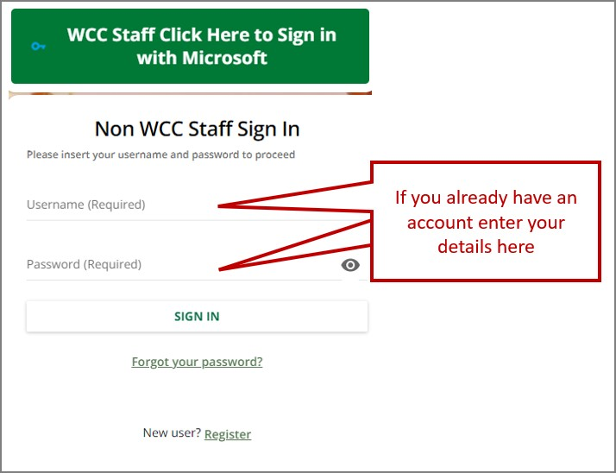

**Creating a new account**

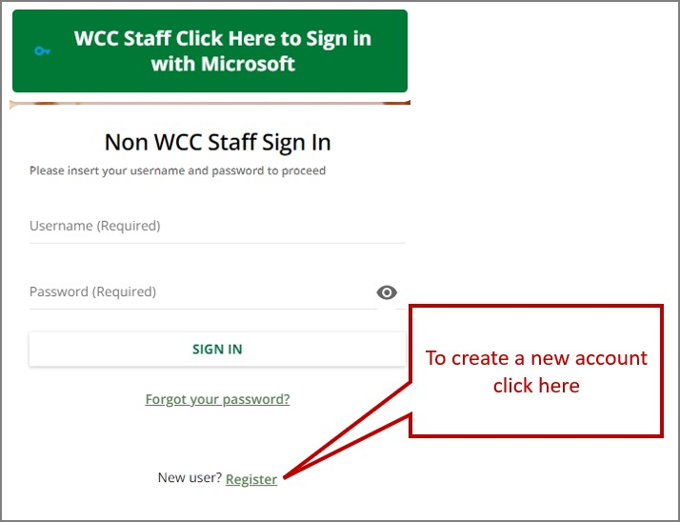

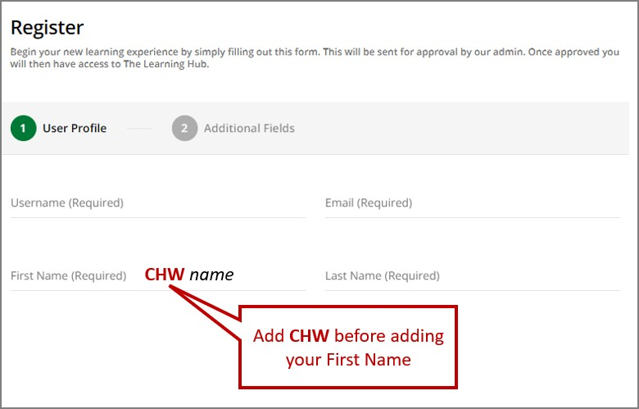

***Important*** When creating a new account please add CHW before putting your First Name. Please see example below. Please then wait until the account is approved within working hours - Monday to Friday 8:30 am to 16:30 pm.

# How to access the course

1. Enter the course code **NS170** in the search box:



1. Click on ‘**ENROL**’

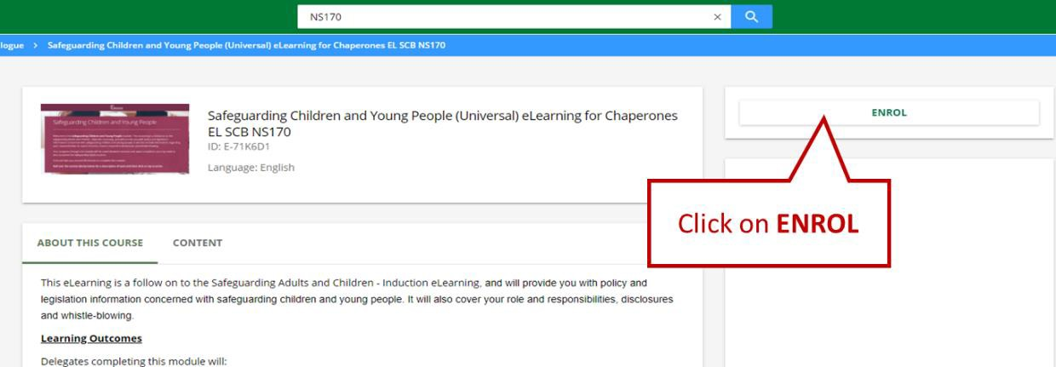

1. Then click ‘**START LEARNING NOW**’

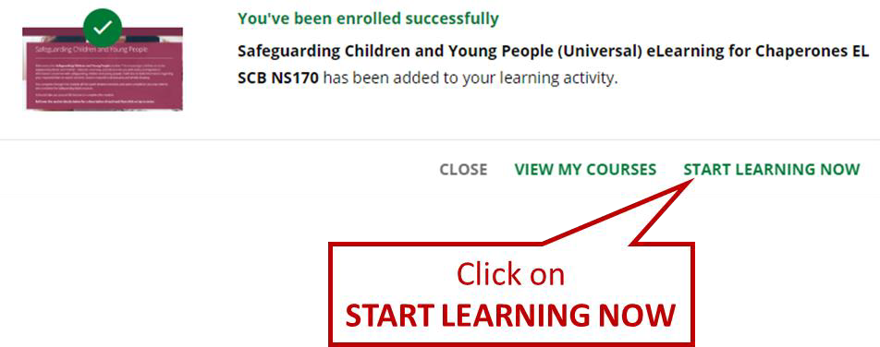

1. Click on **START LEARNING NOW**

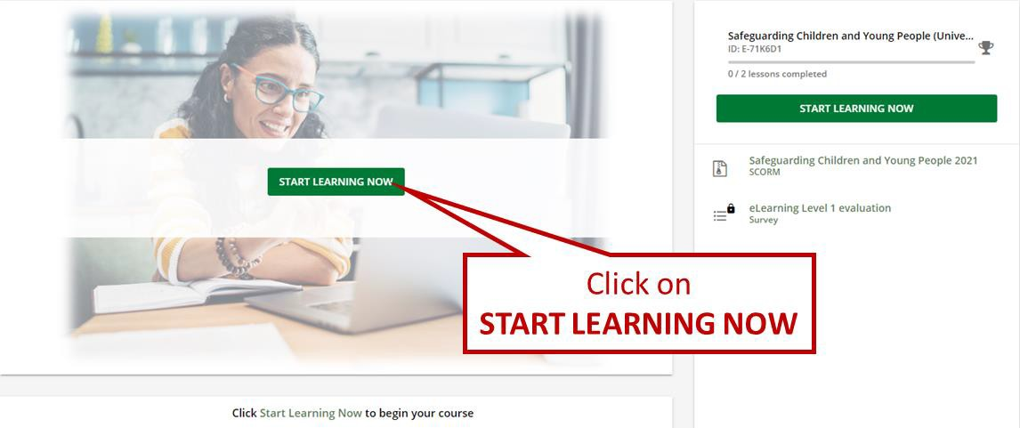

1. You are now ready to complete the module.

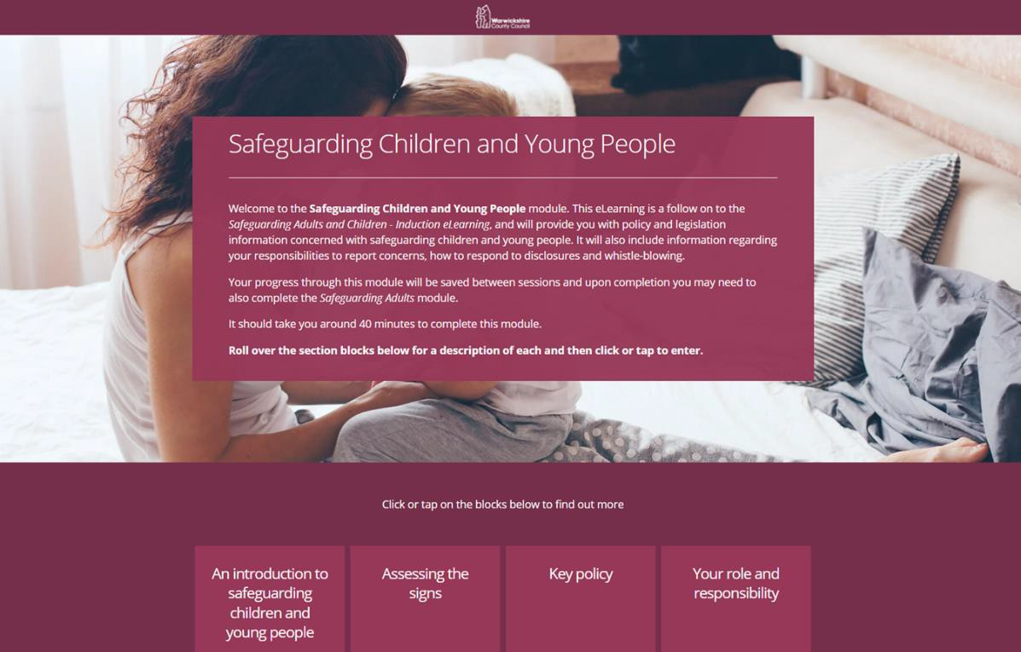

To complete course **Safeguarding Adults & Children - Induction 2020 eLearning EL IND NS490**, repeat from **step 1** using course code **NS490**.

For any queries on this training or access information, please contact [**learning@warwickshire.gov.uk**](mailto:learning@warwickshire.gov.uk)

**THAT’S THE WHOLE PROCESS COMPLETE NOW IF YOU HAVE READ THROUGH THE WHOLE DOCUMENT. PLEASE EMAIL EVERYTHING IN TO US.**

[chaperones@warwickshire.gov.uk](mailto:chaperones@warwickshire.gov.uk)

Chid Employment and Children in Entertainment Team