

Are you a Carer for someone with a learning disability?

Do you like speaking up for yourself and other Carers?

Warwickshire Learning Disability Partnership Board (LDPB) is looking for a **Learning Disability Carer Representative** to come to our Board meetings which are held every three months in either Nuneaton or Leamington Spa.

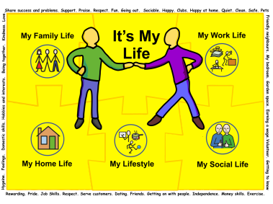

If you want to contribute and have some time to represent Carers please contact me,

Dee Sage at Warwickshire County Council on

01926 742414 or [deesage@warwickshire.gov.uk](mailto:deesage@warwickshire.gov.uk) or for more information go to the Learning Disability Partnership Board (LDPB) website which can be found at

<http://www.warwickshire.gov.uk/ldpb>