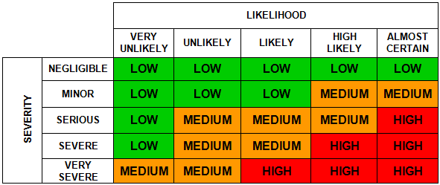

Risk Assessment
Form

Risk Assessment for (Activity/Process/Operation)

Service |  | Team / Section
Assessment Date |  | Review Date |  | Reference Number

What are the hazards  (i.e. what can cause harm) | Who might be harmed and how?  (e.g. employees, pupils, members of the public, etc. and the significant risk(s))? | What existing control measures are in place to reduce / prevent the risk?  (i.e. what are you already doing?) | Considering existing controls, what is the current risk level  (i.e. high, medium or low – use the matrix above) | Further Action to be taken to control the risk?  (i.e. only record action/additional controls measures you are going to implement) | Assigned to | Completed by whom & when

Name of Assessor |  | Signature

Name of Manager responsible for activity / process |  | Signature

Risk Assessment Review Log

Only use this log to confirm that there have been no changes to the current assessment; otherwise an updated risk assessment must be done

Initial Review Date
Assessor’s Signature |  | Date:
Signature of Responsible Manager |  | Date:

Next Review Date | 12 months from initial review
Assessor’s Signature |  | Date:
Signature of Responsible Manager |  | Date:

Initial Review Date | 24 months from initial review
Assessor’s Signature |  | Date:
Signature of Responsible Manager |  | Date:

Initial Review Date | 36 months from initial review
Assessor’s Signature |  | Date:
Signature of Responsible Manager |  | Date:

Initial Review Date | 48 months from initial review
Assessor’s Signature |  | Date:
Signature of Responsible Manager |  | Date:

Risk Assessment(s) for (Activity/Process/Operation)

This form can be used to record and demonstrate that the above risk assessment(s) has been provided to relevant employees (as below) to inform them of the risk assessment findings (i.e. the hazards, risks, and control measures associated with their work).

Name of Persons involved in the Activity/ Process/ Operation | Signature | Date

