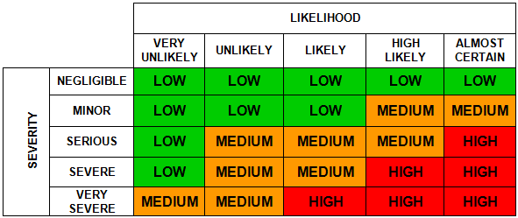

Risk Assessment
Form

Risk Assessment for (Activity/Process/Operation) | EXAMPLE - for employees who drive their own car on WCC Business (including examples of control measures to be considered – it is by no means a fully comprehensive list. It is provided as a guide to get you started)

Service |  | Team / Section
Assessment Date |  | Review Date |  | Reference Number

What are the hazards  (i.e. what can cause harm) | Who might be harmed and how?  (e.g. employees, pupils, members of the public, etc. and the significant risk(s))? | What existing control measures are in place to reduce / prevent the risk?  (i.e. what are you already doing?) | Considering existing controls, what is the current risk level  (i.e. high, medium or low – use the matrix above) | Further Action to be taken to control the risk?  (i.e. only record action/additional controls measures you are going to implement) | Assigned to | Completed by whom & when
Driver suitability  - Medical conditions,  - Attitude,  - Experience and  - Driving history | All employees driving cars  Unable to drive safely, collisions, death | - Employee informed about their responsibilities as per the Driving at Work Policy.  - Employee self-declares driving licence details on HRMS (or vehicle document record form) annually.  - Employee to consult line manager if they are unsure about driving for any reason at any time.  - Employee must ensure they drive in accordance with the laws of the road, signage, and Highway Code (which includes fitness to drive).
Driving  - Lack of familiarity with area, directions or routes  - Driving under the influence of drugs or alcohol or prescribed medicines  - Eating, drinking or using a mobile phone at the wheel  - Speeding  - Long driving times (more than two hours non-stop driving) | All employees driving cars  Feelings of pressure  Unable to drive safely  Collisions  Criminal record  Fatigue | - Employee must plan business journeys in accordance with the Travel Code of Conduct.  - Employees must be fit to drive. If fitness to drive is impaired they must inform their line manager immediately and notify DVLA as required.  - To gain familiarity with the route, employees should plan their route using the information available (such as colleagues knowledge, the AZ or internet route planners, such as www.rac.co.uk www.theaa.com www.greenflag.com)  - Employees will allow themselves sufficient journey time when scheduling/ travelling to work appointments.  - Employees are not to drive if they are under the influence of alcohol or drugs. Should an employee be found to be under the influence then this is gross misconduct as specified in the ‘dismissal and disciplinary procedure’.  - Employees must follow the advice provided for prescribed medicines. Inform your line manager if driving activities are not to be undertaken as a result of taking prescribed medication.  - Employees must comply with the laws of the road and not eat or drink whilst driving.  - Whilst driving mobile phones must not be used as per the Travel Code of Conduct (i.e. ‘calls must not be answered or initiated whilst driving’)  - Employees must take a 15 minute break for every 2 hours of continuous driving.
Working alone | All employees driving cars  Violent incident | - Reference your own specific risk assessments for personal safety/lone working.
Unroadworthy vehicle | All employees driving cars  Collision, loss of control and power, and breakdown | - Employees should have a vehicle that is fit for purpose and in a safe condition – the employee is required to self-declare that they have a valid MOT (where required) when any expenses claim is made.
Driving at night and in poor weather conditions (rain, fog, snow or ice) | All employees driving cars  Unable to drive safely, collisions and injury | - Employees must follow the Highway Code.  - On days of inclement weather an assessment will be made by their line manager as to whether journeys should be made. Business continuity plans are in place. Managers will follow the ‘attendance at work in bad weather conditions’ advice that is available on the HR internet.  - Flexibility to arrive later/delay visit is provided and agreed as required.
Road Traffic Incident/ Breakdown | All employees driving cars/other road users  Physical injury | - Comply with Highway Code and Employees to utilise own breakdown provision for own car.  - Work-related incidents to be reported on the WCC Accident/Incident reporting system  - Employees must use the correct vehicle safety devices e.g. seat belts
There may be other risks specific to your service or school that you want to include here (for example, passenger behaviour if a significant risk)

Name of Assessor |  | Signature

Name of Manager responsible for activity / process |  | Signature

