DO NOT PRINT THIS PAGE

INSTRUCTIONS FOR USE:
This Word document is designed to be editable as follows –
- Add your logo to Page 1: Click on the placement image. Right click and select ‘Change Picture’. When the selected picture is added, it will resize to the same size as the placement image.
- Highlighted copy can be replaced as necessary, and the highlight removed (select ‘No Colour’).
- The table can be completed with necessary details.
- Print pages 1-5 for parent/carer to read and complete.

https://www.edpsyched.co.uk/ebsa-horizons-schools



Dear Parent/Carer,
We understand that children and young people may occasionally miss school for various reasons. Sometimes this is related to their physical health, their mental well-being, or a range of other school / family related factors.
Our primary goal is to create a safe and supportive school community where your child can thrive. To achieve this, we want to support them through a compassionate and child-centred approach; one where we understand what may make attending school more or less challenging. In doing so, we hope to not just improve attendance, but to also nurture your child's social, learning and emotional progress.
Over the past .....X..... weeks, we have noticed that .........Child’s name ....... has missed some school days, and we would like to gain a better understanding of the reasons why they haven’t been able to attend school. These absences are highlighted in the table we have provided for your convenience. You will find a list of possible reasons for each half or full day of absence. Please select the reason that best explains each absence and return the attached pages, so we can gain a better understanding of how we can support your child in school.
If your child is facing challenges attending school, particularly related to anxiety or emotional concerns, please reach out to us for support. We want to work together with you to create strategies that will help your child feel more at ease and confident in school. Please know that we are here to help, and we greatly value working together to foster your child's education.

Yours sincerely,

Name
Role etc.

Child’s Name: XXXXXXXXXXXXXXX

Date of Absence | AM | PM | Reason (see checklist e.g. C1)

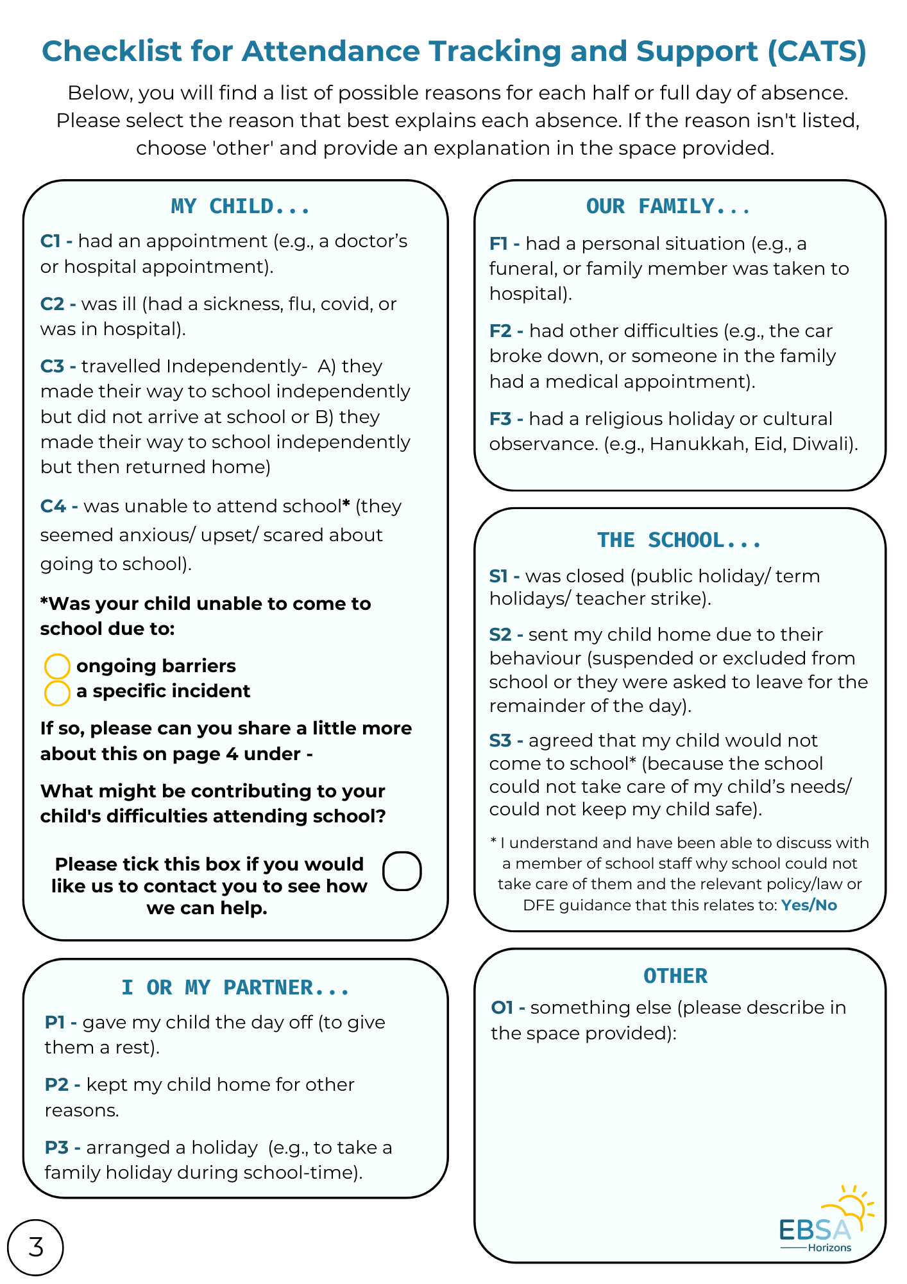
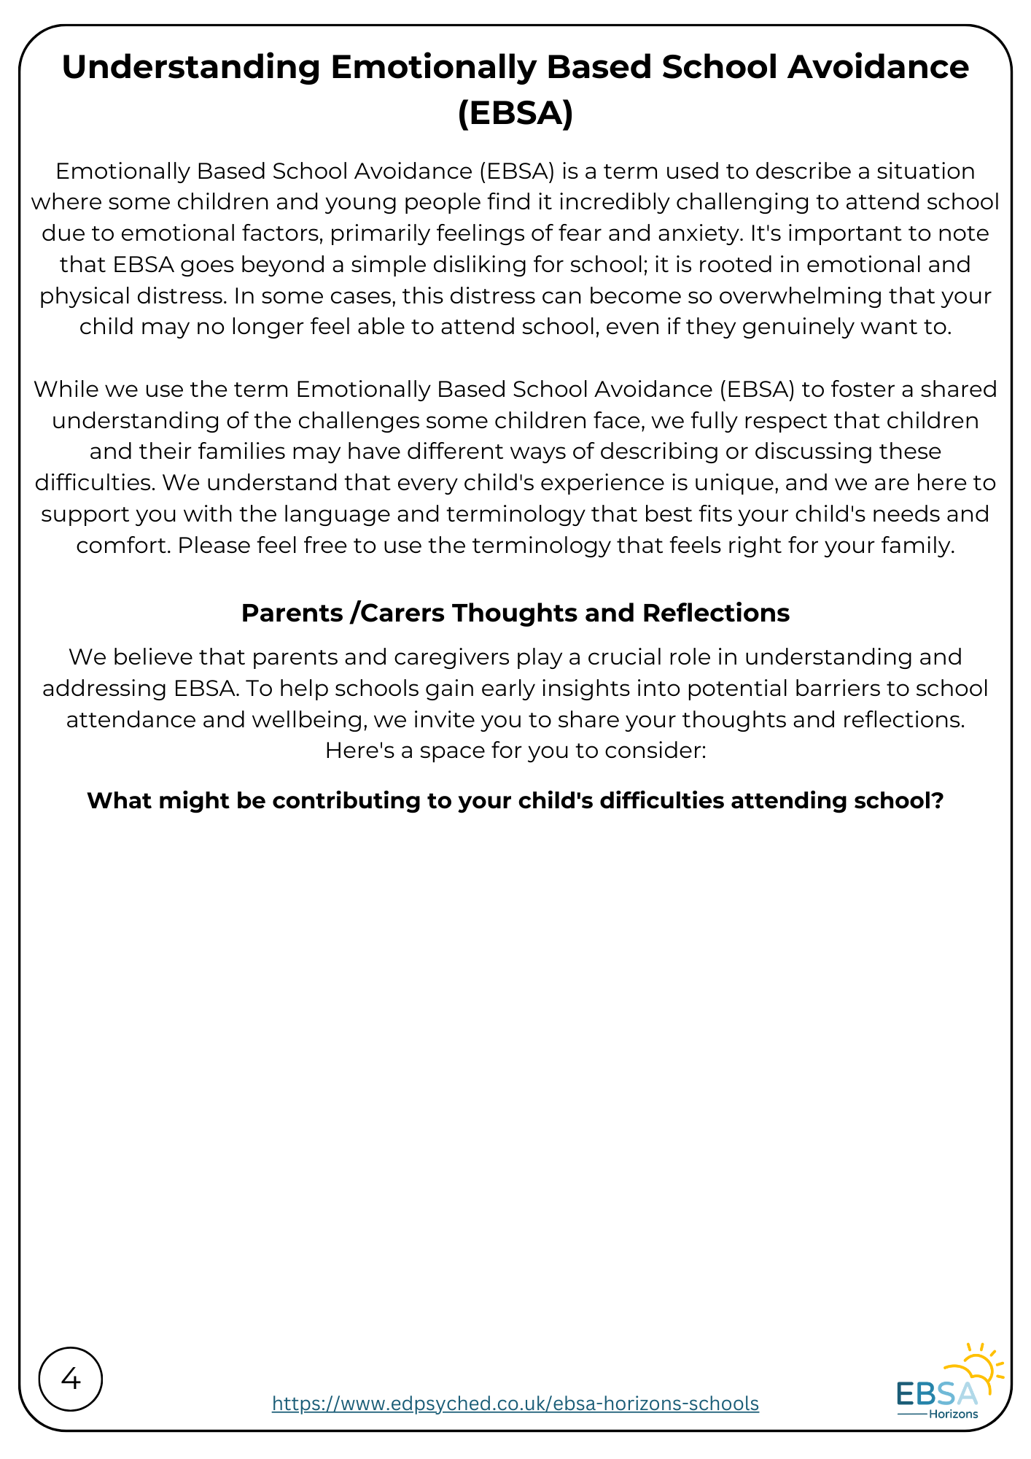
Please fill out this text box...
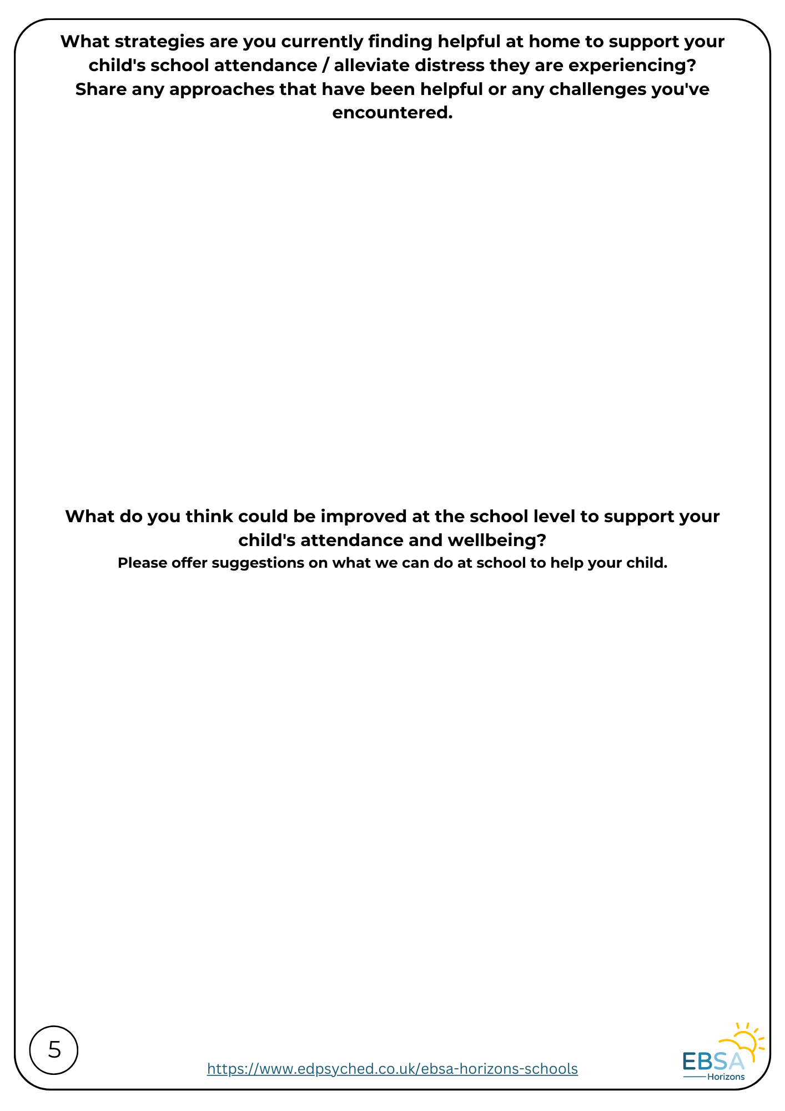
Please fill out this text box...

Please fill out this text box...

