This form is used for Community Early Support Plans only.

The purpose of this review is to work together to identify what has gone well, discuss what we are still concerned about, revisit original actions and decide on any new actions.

We will look at progress made against the actions on the plan and identify any additional support that may be available to you. We will also review the support you have already accessed and discuss if you are waiting to hear about any referrals or are on any waiting lists for support.
Community Early Support Plan Review

Your Early Support Plan

Review Meeting Details
Child(ren) name(s): | Click or tap here to enter text.
Date of Review Meeting: | Click or tap to enter a date.
Name, organisation and contact details of lead professional: | Click or tap here to enter text.
Is this the final review? Is this plan closing? | ☐ Yes ☐ No

Children/young people and other family members involved in reviewing and developing the plan
Name | Relationship | Any needs or barriers? | Attended review?
. | . | . | .
. | . | . | .
. | . | . | .
. | . | . | .
. | . | . | .
. | . | . | .
. | . | . | .
. | . | . | .

Please record any up to date parent/carer addresses, telephone numbers, email addresses here if they have changed recently
.
Lead professional views (please include reasons for closure if plan is closing)
.

Other Professionals involved in reviewing the plan
Name | Role | Organisation | Telephone | Email | Attended review?
. | . | . | . | . | .
. | . | . | . | . | .
. | . | . | . | . | .
. | . | . | . | . | .
. | . | . | . | . | .
. | . | . | . | . | .
. | . | . | . | . | .

What’s going well?
Community Early Support Plan Review

Your Early Support Plan
.

What are the barriers to improving outcomes for the child(ren)/family?
.

Has information from the plan been shared with family members or any other agency/ professional? Provide details of where relevant information (from plan) has been shared with family members/other agencies/professional, as required.
.

Voice of the child(ren)

.
Voice of the parent(s) / carer(s) and significant others.
.

Child and Family Plan
What is the outcome we are working towards? | What action needs to be taken to achieve the outcome? | Who will be responsible for this action? | Timescale
dfsdfsd | . | . | .
dfsdfsd | . | . | .
dfsdfsd | . | . | .
dfsdfsd | . | . | .
. | . | . | .
. | . | . | .
. | . | . | .
. | . | . | .
. | . | . | .
. | . | . | .
. | . | . | .
. | . | . | .
. | . | . | .
. | . | . | .
. | . | . | .
. | . | . | .
. | . | . | .
. | . | . | .
. | . | . | .
. | . | . | .
. | . | . | .
. | . | . | .
. | . | . | .
. | . | . | .

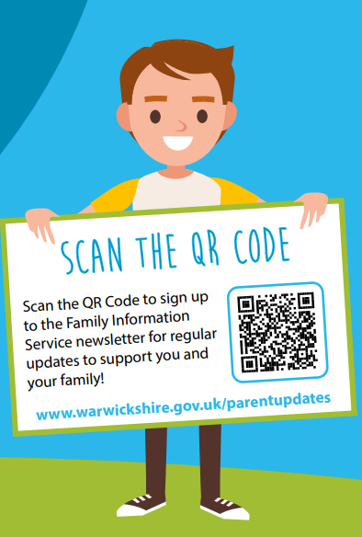
Spectrum of Support
Warwickshire’s Spectrum of Support is a framework for professionals who are working with children, young people, and families. The document provides guidance and helps to identify circumstances when children may need additional support to achieve their potential.
Family Information Service Helpline
01926 742274
You can find additional support, advice and information at www.warwickshire.gov.uk/childrenandfamilies.

Agreement
I understand and accept the need for communication between professionals to complete this assessment. I understand that my information will be stored and used for the purpose of providing my family with effective support.
I will tell you if I do not agree for parts of my information to be shared and understand this will be respected wherever possible.
Name Click or tap here to enter text. | Parent / Carer Signature  .  ………………………………………………………………… | Date Click or tap to enter a date.
Name Click or tap here to enter text. | Parent / Carer Signature  .  ………………………………………………………………….. | Date Click or tap to enter a date.

Date of Next Meeting
Date Click or tap to enter a date. | Time Click or tap here to enter text. | Venue Click or tap here to enter text.
Please ensure that parent(s) / carer(s) written signatures are placed in the boxes above or proof of consent is provided when emailing a copy of this assessment to earlysupportdocumentation@warwickshire.gov.uk
Please ensure the family receive a copy

