Part 1 - Early Support Assessment – Pathway to Change

Your Early Support Plan
Part 1 – Early Support Assessment and Plan
This part of the assessment should be completed for families receiving
multi agency support.
The assessment consists of:
- Pathway to Change
A tool to support the understanding of your situation and identify solutions.
- Child and Family Plan
A record of what needs to happen, so the right support is put in place for you and your family


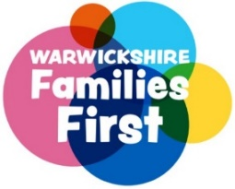

Section 1 - Assessment Details
Date of Assessment: | Click or tap to enter a date.
Name, organisation and contact details of lead professional: | Click or tap here to enter text.
Organisation theme: | Choose an item.
Name and role of anyone else involved in the assessment: | Click or tap here to enter text.

Section 2 - Child Details
Name | Address | D.O. B | Gender | Religion | Ethnicity | Sub ethnicity | Language
. | . | . | . | . | . | . | .
. | . | . | . | . | . | . | .
. | . | . | . | . | . | . | .
. | . | . | . | . | . | . | .
. | . | . | . | . | . | . | .
. | . | . | . | . | . | . | .

Section 3 - Other household members
Name | Address | D.O. B | Gender | Religion | Ethnicity | Sub ethnicity | Language
Name and relationship to child | . | . | . | . | . | . | .
Name and relationship to child | . | . | . | . | . | . | .
Name and relationship to child | . | . | . | . | . | . | .
Name and relationship to child | . | . | . | . | . | . | .
Name and relationship to child | . | . | . | . | . | . | .

Please provide parent/carer email addresses and telephone contact details (required)
Click or tap here to enter text.

Section 4 - Other significant relatives or family friends not living at the address
Name | Address | D.O. B | Gender | Religion | Ethnicity | Sub ethnicity | Language
Name and relationship to child | . | . | . | . | . | . | .
Name and relationship to child | . | . | . | . | . | . | .
Name and relationship to child | . | . | . | . | . | . | .

Section 5 - Education Details
Name of child | Education Setting | Is there an EHCP? | Any other supporting information
. | . | . | .
. | . | . | .
. | . | . | .
. | . | . | .
. | . | . | .
. | . | . | .
Please record any additional information here (including additional children’s/family details if required
.

Pathway to Change
This tool is designed to help us get a shared understanding of your situation and to identify solutions. It is important that the voice of all family members is captured throughout the discussion.

What has happened? What is happening now? Who is affected and how?
.
What positives and strengths are there?
.
What keeps the issue going?
.
What could happen in things don’t change?
.
What is the shared intended outcome of the child(ren)?
.
Voice of the child(ren)
.
Voice of parent(s), carer(s) and the wider network
.
Do the parents/ carers care for a child who has a disability, SEN or significant mental health challenges? Please provide details.
.
Any other additional information (communication needs, immigration status, legal status)
.

IMPORTANT INFORMATION
PLEASE ENSURE YOU COMPLETE THE CHILD AND FAMILY PLAN FOR ALL ASSESSMENTS
If you are completing an Early Support Pathway to Change Assessment,
please skip to Child and Family Plan
You DO NOT need to complete Part 2 – Family Help Assessment unless this has been agreed with your Early Support Officer or Family Connect
Assessment Details
Date Assessment Started: | Click or tap to enter a date.
Date Assessment Complete | Click or tap to enter a date.
Name, organisation and contact details of lead professional: | Click or tap here to enter text.
Organisation theme: | Choose an item.
Name and role of anyone else involved in the assessment: | Click or tap here to enter text.
Part 2 – Family Help Assessment and Plan

This part of the assessment should only be completed following a conversation with an Early Support Officer and/ or Family Connect.

The assessment builds upon the information gathered in the Early Support Assessment (Part 1) above and helps to ensure that the family do not have to repeat their story.

Part 2 – Family Help Assessment and Plan

Your Early Support Plan
Reason for completing assessment
.

Child(ren)’s developmental needs details (growth and learning)
.
Parenting
.
Family and Environmental factors (family and surroundings)
.
What is this telling us? What does it mean for the child and family? What needs to happen next?
.
Are there concerns around homelessness?
.
What might make us more worried for the child(ren) and what would happen then?
.
Please confirm that relevant (necessary) information from assessment/plan has been shared. This should include involved family members, as well as other agencies or professionals (where appropriate). Ensure views of the family members are included with regards information sharing and how it will be managed. Please provide details:
.
Information sharing
We work with partners to provide you with public services. To do this, we may need to share your information. We will do this in a way that protects your privacy. Please let us know when any of your contact details change. You have the right to know what information we hold about you and we try to make sure it is correct.
If you would like further information visit our website: www.warwickshire.gov.uk/privacy
or contact our Customer Service Centre at:
Warwickshire County Council, Shire Hall, Warwick, CV34 4RL Telephone: 01926 410410
The person undertaking this assessment should explain openly and honestly to you what information will be shared, and why.
We collect information so that we can understand what help you and your family may need. If we cannot meet all of your needs, we may need to share all or part of this information with other organisations so they can help us provide you with effective support.
If we need to share further information with any other organisations later, we will ask you about this before we do it.
Consent
We will respect the wishes of children, young people and families who do not consent to share confidential information. However, we will use our judgement if we consider there are concerns which are sufficient to override a lack of consent.
In some circumstances, if parents and carers refuse the provision of early support we will need to consider if we have concerns that a child or young person has suffered, or is likely to suffer, significant harm.
Child and Family Plan (please complete for all assessments)
What is the outcome we are working towards? | What action needs to be taken to achieve the outcome? | Who will be responsible for this action? | Timescale
. | . | . | .
. | . | . | .
. | . | . | .
. | . | . | .
. | . | . | .
. | . | . | .
. | . | . | .
. | . | . | .
. | . | . | .
. | . | . | .
. | . | . | .
. | . | . | .
. | . | . | .
. | . | . | .
. | . | . | .
. | . | . | .
. | . | . | .
. | . | . | .
. | . | . | .
. | . | . | .
. | . | . | .
. | . | . | .
. | . | . | .
. | . | . | .

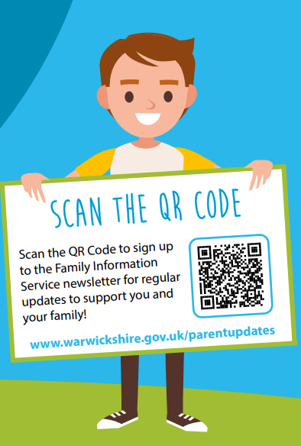
Spectrum of Support
Warwickshire’s Spectrum of Support is a framework for professionals who are working with children, young people, and families. The document provides guidance and helps to identify circumstances when children may need additional support to achieve their potential.
Family Information Service Helpline
01926 742274
You can find additional support, advice and information at www.warwickshire.gov.uk/childrenandfamilies.

Agreement
I understand and accept the need for communication between professionals to complete this assessment. I understand that my information will be stored and used for the purpose of providing my family with effective support.
I will tell you if I do not agree for parts of my information to be shared and understand this will be respected wherever possible.
Name Click or tap here to enter text. | Parent / Carer Signature  .  ………………………………………………………………… | Date Click or tap to enter a date.
Name Click or tap here to enter text. | Parent / Carer Signature  .  ………………………………………………………………….. | Date Click or tap to enter a date.

Date of Next Meeting
Date Click or tap to enter a date. | Time Click or tap here to enter text. | Venue Click or tap here to enter text.

Please ensure that parent(s) / carer(s) written signatures are placed in the boxes above or proof of consent is provided when emailing a copy of this assessment to earlysupportdocumentation@warwickshire.gov.uk
Please ensure the family receive a copy

