**Example 1: Smokefree template letter for Parents/Guardians**

[Insert School logo]

**PROUD TO BE SMOKEFREE/VAPEFREE**

Dear Parent or Guardian,

[Insert name of School] will be adopting a Smoke/Vape free policy. This means you can no

longer smoke or vape throughout our school grounds including:

* outside the school gates
* near school crossings
* on our sports fields

This applies to all school events and activities before and after school. Please note:

It is not law but is a voluntary code. [Insert name of School] has chosen to take this

action for the benefit of our children and parents and carers.

These are the reasons why we have become a Smokefree school:

1. Protect children from harm
2. Three out of four children are aware of cigarettes before they reach the age of

five. Evidence tells us that children are less likely to start smoking if they do

not see it.

1. Two thirds of smokers say they began smoking before the age of 18, when it’s

illegal to purchase cigarettes, and 9 out of 10 began before the age of 19.

1. Children exposed to second hand smoke are at much greater risk of cot

death, meningitis, lung infections and ear disease.

1. A child or parent who already has asthma or other respiratory conditions is at

a high risk of being affected by second hand smoke, even brief exposure can

trigger an attack. Children are powerless to protect themselves from the

dangers of second-hand smoke ...but you can!

There is help available to give up smoking.

For Children and Young People Vaping

**Contact COMPASS**

Visit: <https://www.compass-uk.org/services/warwickshire-cypdas/>

Call: **01788 578 227**

Email: [compass.warksypsduty@nhs.net](mailto:%20compass.warksypsduty@nhs.net)

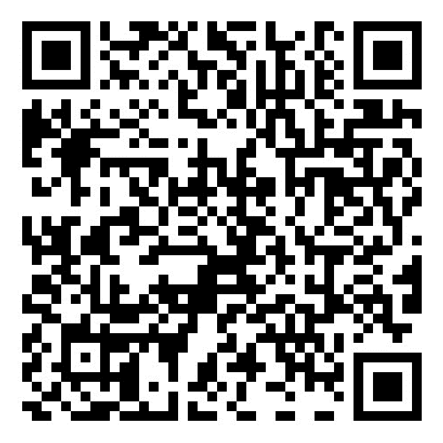For Anyone smoking over 12

**Fitter Futures Warwickshire Stop Smoking Service**

Call:0333 005 0092

Visit: https://fitterfutures.everyonehealth.co.uk/stop-smoking-service/

Text: QUIT to 60777

We would like your support in making [Insert name of School] a Smoke/Vape free school

and community. You can make the difference!

[Signature]

Head Teacher

[Insert name of School]