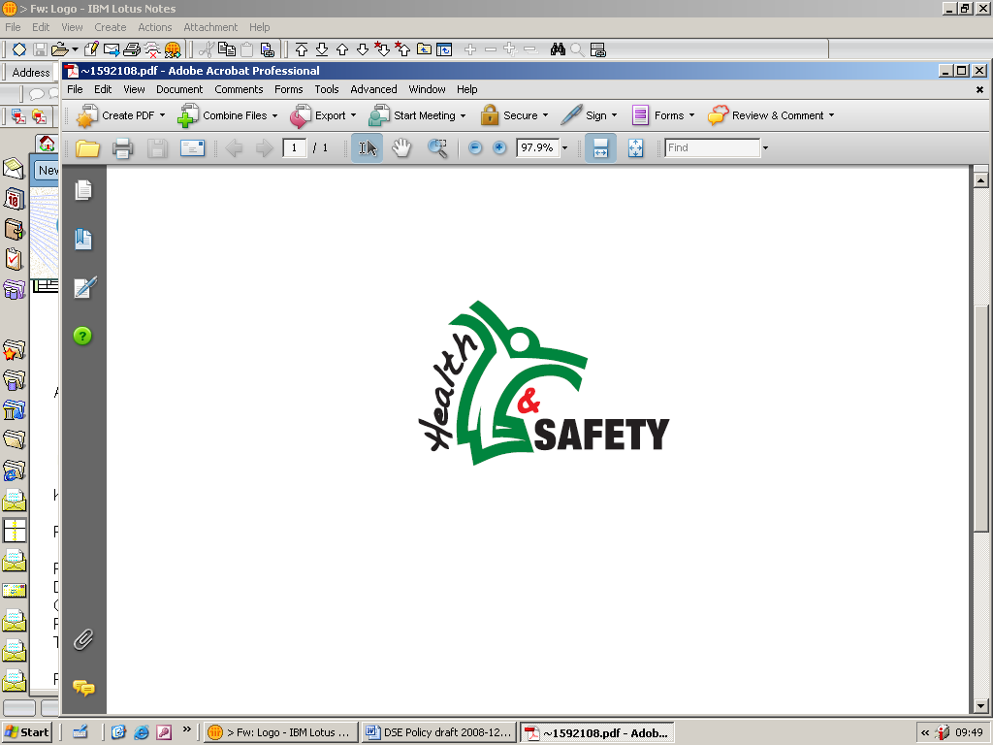

**Display Screen Equipment (DSE) Assessment Referral Form**

The purpose of this form is to ascertain the relevant information that will enable the Health & Safety Service to undertake a suitable and sufficient DSE assessment. Providing us with as much background information as possible about the employee will assist us to provide a more detailed assessment. Disclosure of any existing medical conditions or concerns however all details provided are held securely and any recommendations provided without such information may have reduced effectiveness.

|  |  |  |  |  |  |  |  |  |  |  |  |
| --- | --- | --- | --- | --- | --- | --- | --- | --- | --- | --- | --- |
| **Date Learning Hub DSE Package Completed.**  This must be completed prior to requesting an assessment  ***You must attach a copy of a RECENT self-assessment with this referral which has been completed within one month of the referral date. (N.B. The self -assessment can be completed (more than once) without undertaking the training or quiz )***  ***N.B. The referral form will be returned if this is not attached.***  *For those who cannot access Learning Hub please complete the ‘DSE learning, quiz and self-assessment hard copy’* | | |  | | | Please outline any measures/adjustments that have been introduced following the completion of the recent DSE Self-Assessment | | | | | |
|  | | | | | |
| **Name of Referring Manager** | | |  | | | | | | | | |
| **Job Title** | | |  | | | | | | | | |
| **Contact Telephone Number** | | |  | | | | | | | | |
| **Contact Email Address** | | |  | | | | | | | | |
| **Name of DSE user** | | |  | | | | | | | | |
| **Job Title** | | |  | | | | | | | | |
| **Work Telephone Number** | | |  | | | | | | | | |
| **Work Email Address** | | |  | | | | | | | | |
| **Exact Location of Desk**  *(e.g. Village 1, Ground Floor Barrack Street, opposite breakout area)* | | |  | | | | | | | | |
| **Group***(Communities/Resources/Social Care/ Children &YP)* | | |  | | | | | | | | |
| **Business Unit & Team or School Name** | | |  | | | | | | | | |
| **Please indicate employees preferred days of the week for a DSE Assessment. Please tick as many days as you can and state am/pm if applicable** | | | | | | | | | | | |
| **Monday** |  | **Tuesday** | |  | **Wednesday** | | |  | **Thursday** |  | **Friday** |
|  |  |  | |  |  | | |  |  |  |  |
| **Reason for Referral** | | | | | | | | | | | |
| **Reason For Referral** | | | | | | | **Please Tick** | | | | |
| Personal Request | | | | | | |  | | | | |
| Manager Request | | | | | | |  | | | | |
| Occupational Health Request | | | | | | |  | | | | |
| Resulting from Office Move / Flexible Working | | | | | | |  | | | | |
| Health and Safety | | | | | | |  | | | | |
| Other (please state) | | | | | | |  | | | | |
| **Detail concerns relating to DSE use:**  *It is essential that you provide as much background information about why you are referring this person as possible, including your knowledge of any underlying medical reasons why this person is being referred.* | | | | | | | | | | | |
|  | | | | | | | | | | | |
| **Are there any specific contributory factors that need to be considered?** | | | | | | | | | | | |
|  | | | | | | | | | | | |
| **Working From Home (flexible agreement or otherwise). (Give details and state average days/hours per week)** | | | | | | | | | | | |
|  | | | | | | | | | | | |
| **Does the employee have another job? If so please provide details** | | | | | | | | | | | |
|  | | | | | | | | | | | |

**Confirmation of Consent – For Line Manager Completion**

|  |
| --- |
| I can confirm that the employee is aware of the purpose and content of this referral and has agreed to a report being supplied in confidence to myself (the manager) with a copy to them.  I also understand that as part of the DSE assessment that is undertaken by H&S, recommendations may be made for equipment which could incur a cost to my budget.  It is understood that the DSE Assessment is not conducted by a medical professional. Any specific medical issues should be directed to a GP / Occupational Health. |
| **Signed:** |
| **Print:** |
| **Date:** |

Please attach the completed referral form together with the DSE self-assessment form on a ticket to be raised via the Service Desk Hornbill/HR/H&S, confirming that you wish us to undertake the DSE assessment and provide consent as above.

If you have any queries with regard to the completion of this form or the process please contact the H&S Service via Hornbill, or on 01926 476803.