

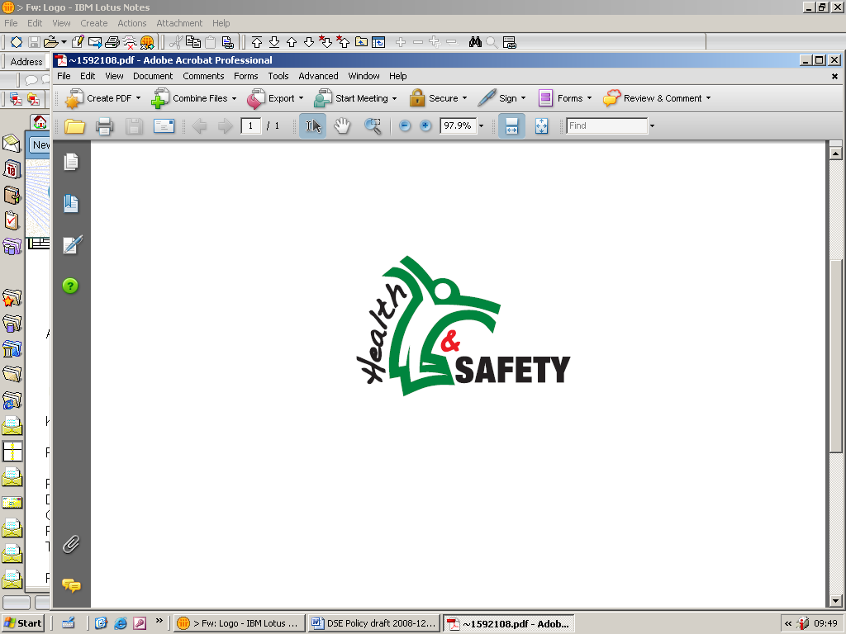
WARWICKSHIRE COUNTY COUNCIL

REQUEST FOR A DISPLAY SCREEN EQUIPMENT (DSE) EYE AND EYE SIGHT VOUCHER (SCHOOLS ONLY)
Name of Employee |  | Group /  /Team
Email or postal address for voucher to be sent |  | Cost code and Cost Centre Detail for voucher recharge
I am the line manager/supervisor of the above employee and can confirm that the above employee is a Defined DSE-User (as defined below). Please provide the employee named above with a free eye and eye sight test voucher as per the corporate scheme.
Manager Signature (or e-signature) |  | Print Name (in full) |  | Date
Cost Centre Manager Email
Cost Centre Manager Signature (or e-signature) |  | Print Name (in full) |  | Date

INFORMATION FOR THE EMPLOYEE
Please obtain your voucher before booking your appointment with Specsavers. You will be sent an eye test voucher either by email or post which you can use at any Specsavers Opticians. This voucher will entitle you to a free eye and eye sight test. If the optician confirms that glasses or corrective lenses are required solely and specifically for DSE use, free glasses or corrective lenses up to the value of £45 will be provided (this will cover a basic pair of DSE glasses/corrective lenses). You will need to confirm with the optician if you meet the “solely and specifically” criteria in accordance with the DSE Regulations before purchasing your glasses or corrective lens.
You may decide to purchase more expensive glasses or corrective lenses and you will then be provided with a minimum £45 contribution towards the cost of these other frames. This may rise to a £65 contribution dependant on the range chosen (i.e. premium club if selecting frames from the £99 or above range). The remainder is paid direct to Specsavers by you. Please note if you decide to go for the buy 1 get 1 free offer the extra £20 discount will not be available to you. More information is available in the WCC DSE Employee Guide.

If the optician prescribes corrective appliances for general use, incorporating a special prescription for DSE use, you will not be entitled to free glasses or corrective lenses. However, you are entitled to a contribution of £20 towards the cost of any frames costing £99 or above by using this same voucher.

You can also request a maximum of two free Specsavers Premium Club vouchers which can be used by your family which provides them with £20 towards the cost of any frames costing £99 or above. Please request these vouchers separately by email when requesting your own voucher.

MANAGERS GUIDANCE ONLY

Definition of Defined DSE-User - is someone who habitually uses DSE as a significant part of their normal work. It is up to line managers to determine which employees fall within the definition (part time workers will also need to be assessed). An employee would usually be classified as a Defined DSE-User if all of points 1-3 are met and one of points 4-6 below:
- Use DSE for continuous or near-continuous spells of an hour or more at a time; and
- Use DSE in this way more or less daily; and
- Have to transfer information quickly to and from the DSE; and
- Need to apply high levels of attention and concentration; or
- Highly dependent on DSE; or
- Need special training or skills to use the DSE.

Please send the completed form to healthandsafety@warwickshire.gov.uk to obtain your voucher. For more information on DSE visit the Health and Safety Pages on the intranet or the Schools document library www.warwickshire.gov.uk/SchoolHSDocs

