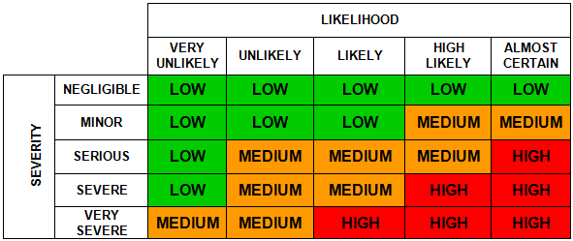

Risk Assessment Form

Risk Assessment for (Activity/Process/Operation)

Service |  | Team / Section
Assessment Completion Date |  | Next Assessment Review Date |  | Reference Number

 | What are the hazards?  (i.e. what can cause harm, eg slips, trips, falls, manual handling, lone working) | Who might be harmed and how?  (e.g. employees, pupils, members of the public, etc. and the significant risk(s) eg fracture, muscle strain, fatality)? | What are you already doing to control the risks?  (e.g. what controls do you have in place? e.g. physical barriers, training, documentation, PPE) | Considering those controls you are already doing, what is the current risk level?  (i.e. high, medium or low – use the matrix above) | What further action can be taken to control the risk?  (i.e. only record action/additional controls measures you are going to implement, e.g. introduce a lone working buddy system, provide additional training) | Who needs to carry out the action and when is the action needed by? | Action completed (Date)

Name of Assessor |  | Signature
Name of Manager responsible for activity / process |  | Signature
This form can be used to record and demonstrate that the above risk assessment(s) has been provided to relevant employees (as below) to inform them of the risk assessment findings (i.e. the hazards, risks, and control measures associated with their work).
Name of Person involved in the Activity/Process/Operation | Signature | Date

