Personal Security

Every visitor is asked to sign the in and out visitor's book at the main entrance and to wear identification. Please keep your valuables with you at all times.

If you do leave the building for a short time, please exit through reception, informing the ofﬁce as you go. Please do not prop open any doors which could allow access to unauthorised individuals.

Accident
Reporting

All accidents, near misses or other incidents must be reported to the ofﬁce staff as soon as possible.

Smoking
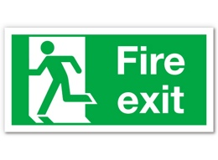
In order to maintain a healthy and safe environment, smoking is not allowed within the school buildings or the grounds. Please respect our no smoking policy.

Fire Precaution

In the event of a continuous alarm sounding at any time, everyone must leave the building immediately using the nearest ﬁre exit -all clearly marked. You will be directed to the relevant assembly point. Please wait to be accounted for.

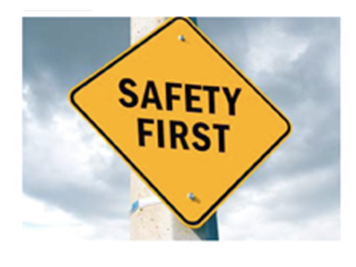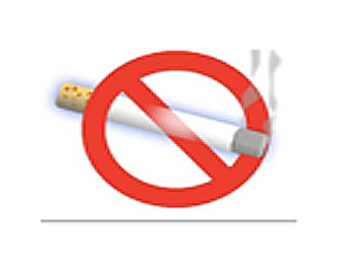

First Aid
In the event of injury or ill-health, please contact a member of staff who will assist and enlist the help of a trained person. If you have a medical condition that you would like us to be aware of (so we can offer some help should it become necessary), please inform a member of staff on arrival.

Work Equipment
Contractors coming on the site must report to the ofﬁce staff before commencing work.

Contractors must supply their own equipment.

All electrical equipment brought onto the site must comply with the current legislation, and have been tested in line with the Electricity at Work Regulations 1989.

If you require any assistance, please ask a member of staff who will be pleased to help.

Any portable hand
held power tools must be used at 110V.
Asbestos
Contractors should sign to say they have received relevant asbestos information before commencing any work. This is located electronically on the WCC ATLAS system.

COSHH

If you are bringing materials on site that are covered by the COSHH Regulations you must have the relevant safety data.
