

Warwickshire County Council

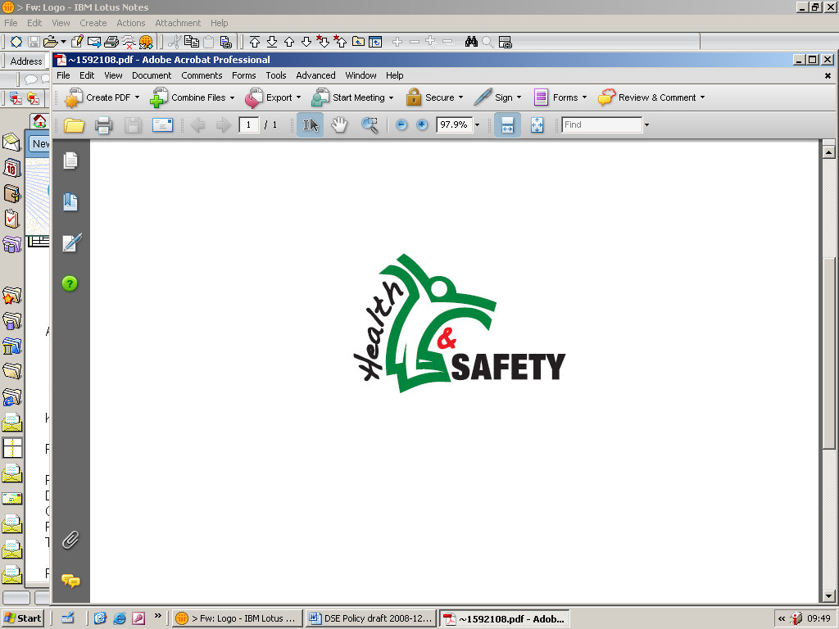
First Aid Needs Assessment Guide

1.0 Purpose
This document details WCC guidance on undertaking First Aid Needs assessment and recording them within WCC to support WCC Policy.

- The First Aid Needs Assessment Form

This first aid needs assessment can be used for any WCC workplace, premise or work activity. To use the assessment form, each column must be considered from left to right.

Managers/ Site Responsible Persons will therefore work out the basic first aid provision requirement, and then identify other considerations which may require that basic provision to be increased or provided in an alternative way (for example, within shared buildings the provision covers all building occupiers rather than just a particular team so liaise with other colleagues). Managers /Site Responsible Persons must ensure that minimum cover must be place at all times during the working day.

2.1 Reviewing of First Aid Needs Assessment

The manager should review the individual assessment every 12 months and if nothing has changed since the last review and the assessment is still considered adequate and is up to date then, the manager may sign the assessment off for another 12 months.

2.2 Recording of First Aid Needs Assessment

Managers/ Site Responsible Persons record the provision they require along with the names of personnel who will undertake the first aid duties. The Manager/Site Responsible Person is responsible for ensuring that the any requirements from the first aid needs assessment are actioned e.g. more first aiders, refresher training of existing first aiders, new first aid box. First Aid Needs assessments must be made available and brought to the attention of all relevant staff.

If you have any doubts, concerns, or queries about completion of a First Aid Needs Assessment please contact healthandsafety@warwickshire.gov.uk or tel 01926 476803.

WCC First Aid Needs Assessment - Guidelines and Record Sheet

Team |  | Group
Building location |  | Building Name
UPRN number |  | Date of this Assessment
Assessor |  | Date to review (Annual)
Before completing this First Aid Needs Assessment, please tick box to confirm that you have read First Aid Guidance in relation to COVID19 (COVID First aid guidance can be found on HSW section of the Intranet)

On the below, tick what applies for your workplace and activities so that this record can be retained as your first aid needs assessment.
As per WCC First Aid at Work Policy, is this assessment for:
Large shared low risk office building¹ Specific work activity

¹Note, Even if you work within a large shared office building, the nature of your work activity may warrant its own first aid provision

Overall workplace risk | No. of employees  (i.e in the premise or as part of the activity this covers) | Basic minimum.  This provision should be available at any time during the working day  For all, consider holiday/ sickness cover | Other considerations that may require additional provision to be identified, based on the risk groups and work activity risks  (you will need to ensure that any additional COVID requirements have been considered with reference to the COVID 19 First Aid Guidance)  More trained personnel may then be required or cover may be provided by a neighbouring team in large shared buildings | Additional comments  (please add as appropriate to your workplace, activity, premise)
Low  Examples:  - offices,  - libraries,  - schools (generally) | Less than 25 | One emergency first aider trained to EFAW | In addition to whether your workplace risk is low, medium or high – any of the following may require you to increase your provision from the basic minimum or you may be able to provide it in another way. Tick all that apply and make comments in the next column as necessary:  Proximity to other building with first aid personnel/ based in shared buildings  Proximity to hospital, doctors, fire brigade  Proximity to an Automated External Defibrillator  Remoteness of location  Size, scale and layout of site  Potential for burns, scalds, eye injury, chemical injury, anaphylactic shock, fracture injuries, falls from height.  History of previous accidents (think of number of accidents, cause and injury type)  Pupils on premise/ working with children  School off-site activities/trips  Out of school hours arrangements e.g. lettings/parents evening  School provision for lunchtimes and breaks  Visitors to building  Number and dispersal of visitors on site  Members of the public access building  Contractors working  Distribution of workforce within the building  Lone working, working away from the main premises  Employees and/or visitors with disabilities  New and expectant mothers  Young workers/ inexperienced workers  Employees with existing health problems  Construction work  Shift work  Low risk environment with low number of staff (i.e less than 5)*  Working with foundation stage children**  Operational fire-fighters/ work at  fire station ^  Caring/supporting customers in the community^^
 | 25 – 50 | One emergency first aider trained to EFAW
 | 50 – 100 | Two emergency first aider trained to EFAW
 | 100 + | Two emergency first aider trained to EFAW
Medium – High  Examples:  - Catering  - Forestry  - Highways  - Workshops  - Construction  - Print unit  - Using chemicals  - Using machinery  - Schools (science/ design & technology) | Less than 25 | One First aider trained to FAW
 | 25 – 50 | One First aider trained to FAW
 | 50 + | Two First aiders trained to FAW
Appointed Person* | In exceptional circumstances there may be some workplaces that are low risk with low number of staff whereby the manager/ Site Responsible Person may deem a trained first aider as not being required. In these instances, an Appointed Person may be appointed. However, before the appointment of Appointed Persons the manager/ Site Responsible Person must contact the relevant Group Senior Health and Safety Advisor so as to ensure appropriateness of this first aid provision.  Please note: Even in these small, low-hazard areas where first aiders are considered unnecessary, there is always the possibility of an accident or sudden illness so someone must always be available to take charge of the arrangements (i.e. equipment and facilities) and call the emergency service.

Paediatric first aid ** | Paediatric first aid is the requirement of the Early Years Statutory Framework: foundation stage classes in nursery, infant and primary schools must have at least one person with a current paediatric first aid certificate on the premises at all times when children are present. They must also accompany children on any off site visits/trips.
Operational Fire fighters and fire stations ^ | Office and similar environments within Fire & Rescue will be guided by the above ‘low’ workplace section.  Fire stations and operational environments present a higher level of risk. To ensure sufficient first aiders are available to meet both the requirements of the Regulations and the need to provide trauma care to members of the public at incidents, all EFAD drivers (Fire-fighter role only) and Watch Manager Training Instructors at the TADC will be/remain qualified in first aid and trauma care.  Refer to Fire & Rescue’s Service Order 01.08.16.
Community First Aid ^^ | While there is no statutory requirement to provide first aid to customers, it is strongly recommended that staff caring/supporting people in the community receive, as a minimum, a basic awareness of First Aid.

Now record your first aid provision on the form overleaf.

RECORD OF FIRST AID NEEDS ASSESSMENT

Summary of first aid needs based on the assessment

First aid personnel required
(including training type – e.g. EFAW, FAW, Paediatric; and numbers required)
Deputy/ cover arrangements
First aid equipment needed and numbers
(e.g. boxes which includes the ‘Basic Advice on First Aid at Work’ leaflet)
Manager /Site Responsible Person to record any actions taken following completion of this assessment e.g. arrange training | Action taken | Date actioned

Assessor Signature |  | Date

REVIEW LOG (after 12 months)

I can confirm that there are no changes to this assessment.

Assessor Signature |  | Date

Names of first aid personnel, deputies, training required, refresher date and their location of work.
Inform others of their first aid arrangements as soon as this provision has been implemented.

Name | Work location/ room number | Contact number | Training required  (e.g. type – EFAW, FAW) | Date attended | Date refresher required
 | `

To book all courses contact healthandsafety@warwickshire.gov.uk or telephone 01926 476803

