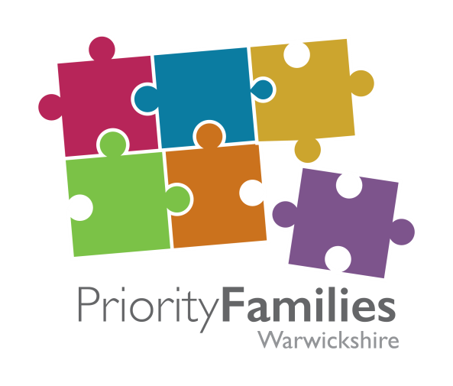

**Priority Families Programme Board 3rd July 2015**

**Short Form Notes of the Meeting**

**Present:**

Sally Lightfoot Warwickshire County Council

Tony Begley Warwickshire Youth Justice and Family Intervention Service

Ian Riley Warwickshire County Council

Monika Rozanski Warwickshire County Council / Public Health

Helen Hunt Warwickshire County Council

Hugh Disley Warwickshire County Council

Victoria Jones Warwickshire Children and Voluntary Youth Service

Debbie Tedds Warwickshire Police

David Gooding BRANCAB

Neil Henderson Safeline

Joy Farrin Job Centre Plus

Seema Gill Employment Advisor (Coventry)

Nick Gower Johnson Warwickshire County Council

Bill Basra Warwickshire County Council

Andy Davis Warwickshire County Council

Sarah Powell Warwickshire County Council

Jemma Bull Warwickshire County Council

**1 Apologies for Absence:**

Nick Cadd, Rachel Jackson, Phil Evans, Karen Manners, Helen King, Jo Prosser, Gill Bishop

**2 Appointment of Chair for the Meeting**

It was agreed that the meeting would be chaired by Hugh Disley.

**3 Matters Arising not otherwise covered by the Agenda**

**Housing Related Support Grant Work:** Once published,Bill Basra to send round the papers on the Housing Related Support Grant work. **ACTION - BBASRA**

**Conference Feedback**: Nick to email Board members the feedback report on the April conference.

**ACTION - NGJ**

**Conference Lessons Learnt:** Nick to add ‘lessons learnt’ to the next Board agenda. The Board committed to holding one conference per year.

**ACTION - NGJ**

**4 Phase 1 Performance**

There was praise for Sarah Powell and Matthew Wand over the clarity and conciseness of the Phase 1 Performance report that her team have produced. The data visualisation produced by Jemma Bull was also well received and it was agreed to continue these throughout the programme.

**0 – 5 Strategy Group Work:** Sarah to arrange to meet with Monika regarding support from Priority Families for data to inform the 0-5 strategy group work. To include Phase 2 families only.

**ACTION - SPOWELL**

**Data Visualisation:** Request to amend the data visualisation to remove the children’s centre reference as it does not cover only families with 0 – 5’s. **ACTION - JBULL**

**Family Rate:** Query over producing a population/family rate alongside reporting on actual family numbers. **ACTION - SPOWELL / ADAVIS**

**Performance Report:** A suggestion by Neil Henderson for the future Phase 2 performance report was to consider including the type of intervention in the performance report. Focusing on the impact of outcomes. For an October report consider:

* Description of interventions
* Evidence of impact and methodology
* Example of impact e.g. case studies – what worked?
* How are interventions measured? – particular mechanisms

**ACTION - SPOWELL**

**5 Child Poverty Strategy**

The Government is reconsidering its approach to Child Poverty - particularly in relation to its view of the perceived causes and performance measures. In Warwickshire the Child Poverty Strategy has been adopted (11th June). Following a suggestion by Hugh Disley it was agreed that the Board would play a governance role in relation to the Strategy for reporting purposes.

Bill provided an update on the Free School Meals project. We have undertaken an exercise to cross match priority family lists with those registered as claiming free school meals which identified a gap between those who are eligible and those who are registered and claiming.

It was agreed that Sally Lightfoot and Monika Rozanski would meet to discuss the emerging 0 – 5 Strategy. **ACTION – SLIGHTFOOT / MROZANSKI**

**6 Phase 2 Progress**

Sarah Powell updated on the latest Phase 2 ‘identified’ priority family numbers – approximately 500 so far but this is growing every day. Nick presented on the change and transformation priorities for Phase 2. There is a growing emphasis on ‘bottom-up – agency referrals’ and the extended Phase 2 criteria appears to be having an effect on the geographical distribution of our families across the county.

**Outcomes Plan:** Send Board members a link to the web pages and advise location of the Outcomes Plan. **ACTION - NGJ**

**Referral and Identification:** Nick to link in with Steve Shanahan (housing providers) and identify individuals to engage with. **ACTION - NGJ**

**Health Data Sharing:** As a Board, raise health data sharing issues with Chris Lewington.

**ACTION – NGJ / HDISLEY**

**Community Forums:** Add priority families and data reports to a future agenda for the Community Forums (countywide). Local leads could present a Phase 1 summary. **ACTION - NGJ**

**CCG Reports:** Discussion around the production of Clinical Commissioning Group reports – Phase 1 summary. **ACTION - SPOWELL**

**0 -5 Strategy:** Hugh and Monika to arrange to meet with Victoria Jones to discuss funding pots and bids around the 0 – 5 strategy. **ACTION – HDISLEY / MROZANSKI / VJONES**

**Prisons:** Nick and Debbie Tedds to have a discussion around prisons and prisoners and data/intelligence. Debbie suggested that Blakenhurst Prison may be a better contact for us.

**ACTION – NGJ / DTEDDS**

**Board Attendance:** The Board agreed that Jayne Spilsbury should be invited to future meetings, all agreed. She is the newly appointed WCC Service Manager for Learning & Performance. **ACTION – NGJ**

**Cost Savings Calculator:** Nick to send out the briefing note for the cost savings calculator Phase 2 submission. **ACTION – NGJ**

**7 Date of Next Meeting:**

**Board Meeting**  19th October 2015 at 10:00am at Northgate House, Warwick