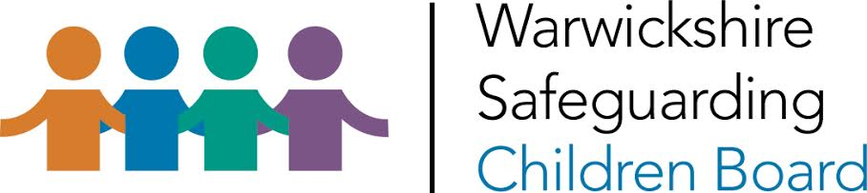

Action plan to address issues identified by annual schools and education settings safeguarding audit
Academic year 2017/18

RAG rating and action planning

The traffic light system relates to how the school/education provider assesses the urgency with which identified areas for development need to be addressed and its progress in addressing them. Actions and areas for development need to be recorded along with the person responsible for completing the action and a timescale in which they will do so.
RED | Indicates that processes are lacking and need to be developed as a matter of urgency.
AMBER | Indicates that processes are in place but they need to be reviewed or further improved.
GREEN | Indicates that although there is an area for development, actions have been identified, work is already underway and there is a high level of confidence about fully addressing the issue within the identified timescale.

Name of school/college/provider: |  |  | Date of audit:
No | Number and title of Audit section | Action needed | Rag rating | Timescale |  | Name and position of person responsible
1.

2.

3.

4.

5.

6.

